Bicarbonate

# Introduction

“**The respiratory system is the main route for the elimination of [13CO2]. The nonrespiratory routes are minimally active**:

* ~1% of [13CO2] is los transcutaneously
* <0.5% in faeces
* 1-3% in urine as urinary urea

“{Sanaka2008}

* “(1) the **delayed pulmonary output results from temporal retention of [13CO2] in the well-perfused tissues (heart, brain, etc.)**, (2) the **incomplete recovery results from incorporation of the label into metabolic products (ketone bodies, amino acids, etc.) or from fixation of [13CO2] in the low-perfused tissues** (bone, skeletal muscle, etc.)” {Sanaka2008}
* “Once the [13C] label enters the systemic circulation as [13CO2], the fate of the label is governed by the flow dynamics of bicarbonates/CO2, which are characterized by distribution and elimination [5]. In the human body, [13CO2] undergoes bidirectional exchanges with the large bicarbonate pools (distribution), is excreted in the breath (elimination), or is lost through nonrespiratory routes (elimination)” {Sanaka2008}
* “This analysis compares the breath recovery of a 13C-methacetin breath test with the actual serum kinetics of the substrate. **It is shown, that breath and serum kinetics of the same test are significantly different over a period of 60 minutes.** The recovery of the tracer **13Co2 in breath seems to be significantly delayed due to intermediate storage in the bicarbonate pool.**” {Lock2009a}
* “Since CO2 cannot freely pass the alveolar semipermeable membrane, a substantial portion of [13CO2] survives pulmonary elimination.
* “13Co2 is not directly exhaled from the target enzyme, but needs to be transported from the investigated organ as bicarbonate(H 12Co3- /H 13Co3-) into the lung [8].” {Lock2009a}
* “It is known that emerging bicarbonate has a relatively long halftime of approx. 60 minutes [14] and that ultimately only 70% of the emerging 13Co2 is excreted [15].” {Locke2009a}
* “The body stores of CO2 are large, so that changes in the metabolic production of CO2 are not instantaneously translated to changes in CO2 elimination (V.CO2) at the mouth.[13]” {Barstow1990}

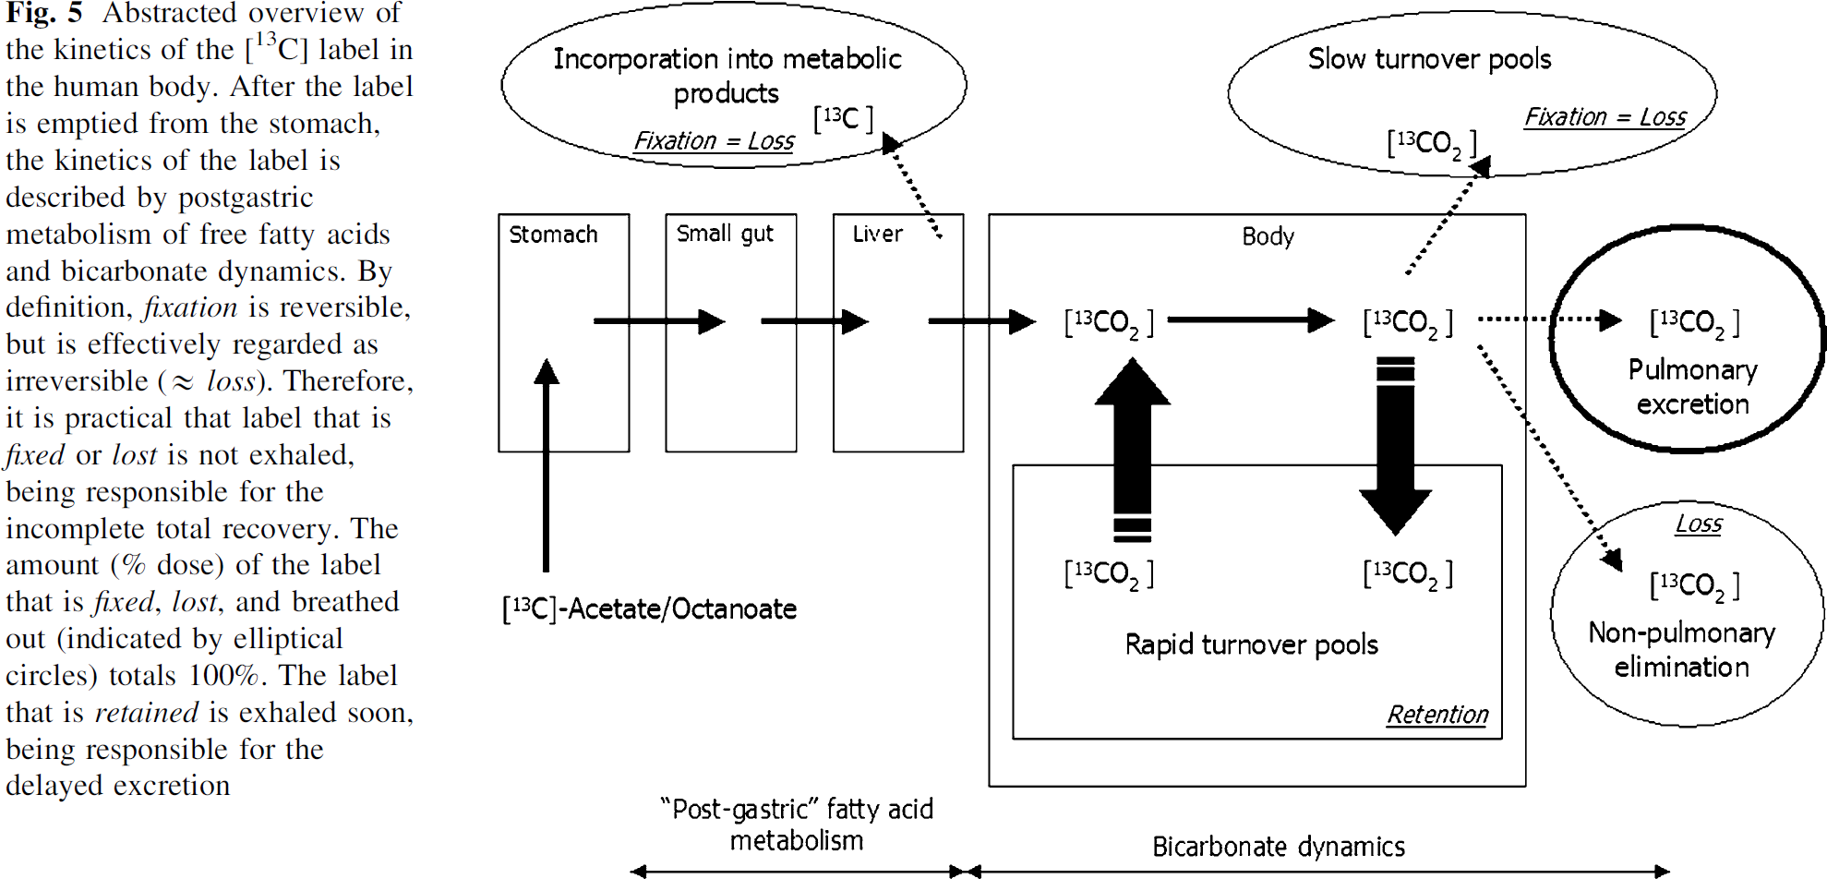{Sanaka2008}

## Bicarbonate Pools

* “The bicarbonate pools are divided into two kinetically distinct groups according to the turnover rate, namely the rapid and the slow turnover pools [12] (Fig. 4)” {Sanaka2008}
* “The washout of bicarbonate as labelled CO2 in the breath under resting conditions has been described by the sum of three exponential terms, implying the presence of at least three major bicarbonate pools with distinct kinetic differences.” {Hall1999}
* “It has been shown that the compartmental dynamics of CO2 transport and storage are very sensitive to changes in acid–base status (Leese et al. 1994) and changes in metabolic rate induced by exercise (Wolfe et al. 1984; Barstow et al. 1990; Tarnopolsky et al. 1991; Leese et al. 1994).” {Hall1999}

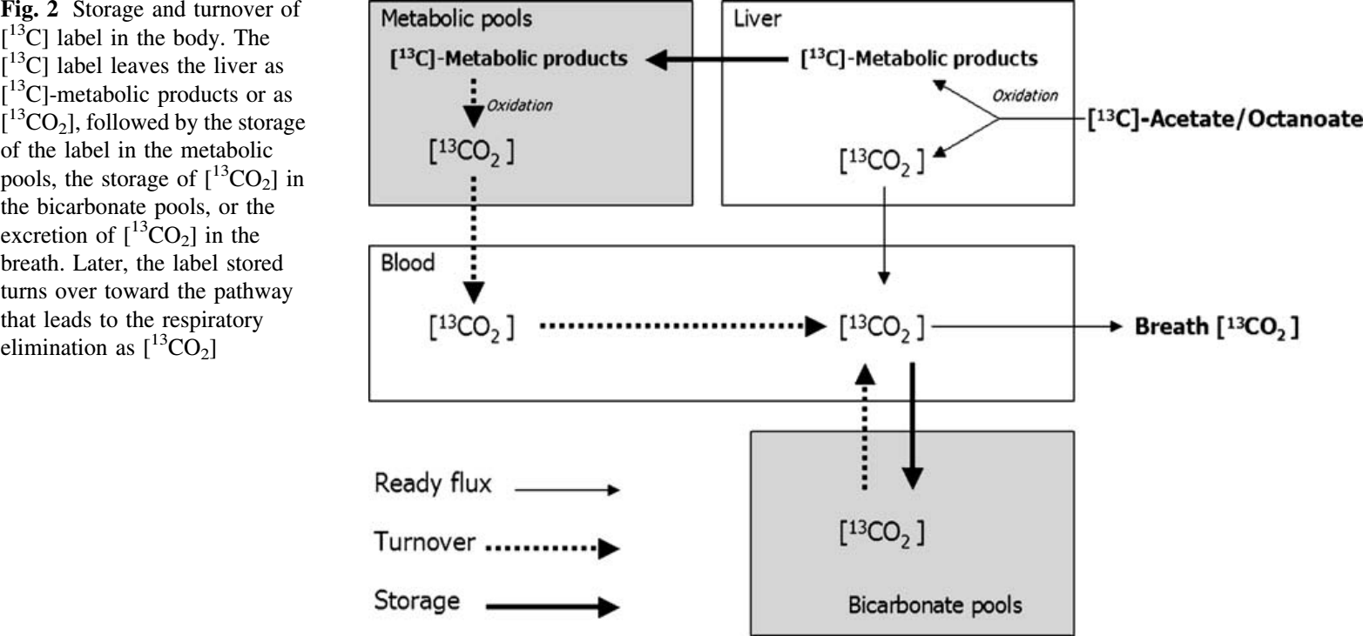{Sanaka2008}

# Exercise

* “With exercise the bicarbonate pool size has been shown to increase several-fold (Barstow et al. 1990; Leese et al. 1994) and mean residence time of 13CO2 in the body is decreased (Leese et al. 1994). In contrast, during recovery from exercise the bicarbonate pool is smaller compared with that at rest; however, mean residence time is still reduced (Leese et al. 1994). The net result of these kineti changes for bicarbonate recovery at rest, during one-leg knee-extensor exercise and during recovery is shown in Fig. 3. **At rest bicarbonate recovery was at steady-state in fasted subjects with a recovery of 82 %. However, at the onset of exercise bicarbonate recovery far exceeded 100 % but returned to approximately 100 % after 1 h of exercise**. In contrast, the bicarbonate recovery early post-exercise was lower (52 %) than at rest before exercise. With increasing time of recovery from exercise, the bicarbonate recovery increased to an apparent steady-state of approximately 96 %. Similar results have been shown previously by other investigators during two-legged cycle exercise (Wolfe et al. 1984, Tarnopolsky et al. 1991) and recovery (Tarnopolsky et al. 1991).” {Hall1999}

#### Barstow1990

* “We examined CO2 dynamics in sex healthy male subjects using an intravenous bolus of [13C]bicarbonate. Subjects were studied while **resting**, during **light exercise** [50% of the lactate threshold (LT), 3-4 times **resting O2 uptake (V.O2)**, and during **moderate exercise** (95% of the LT, **6 times resting V.O2**)” {Barstow1990}

“Average recovery of 13C label rose from 67% during exercise to 80% during light and moderate exercise”.

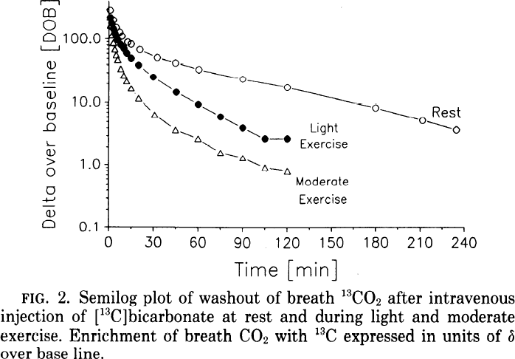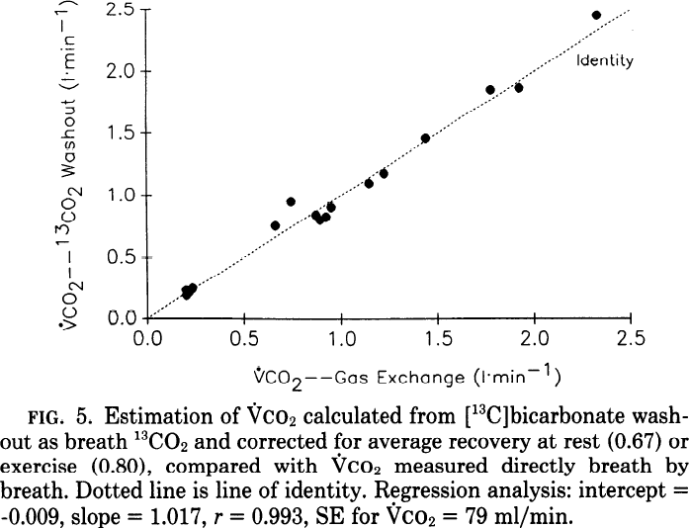

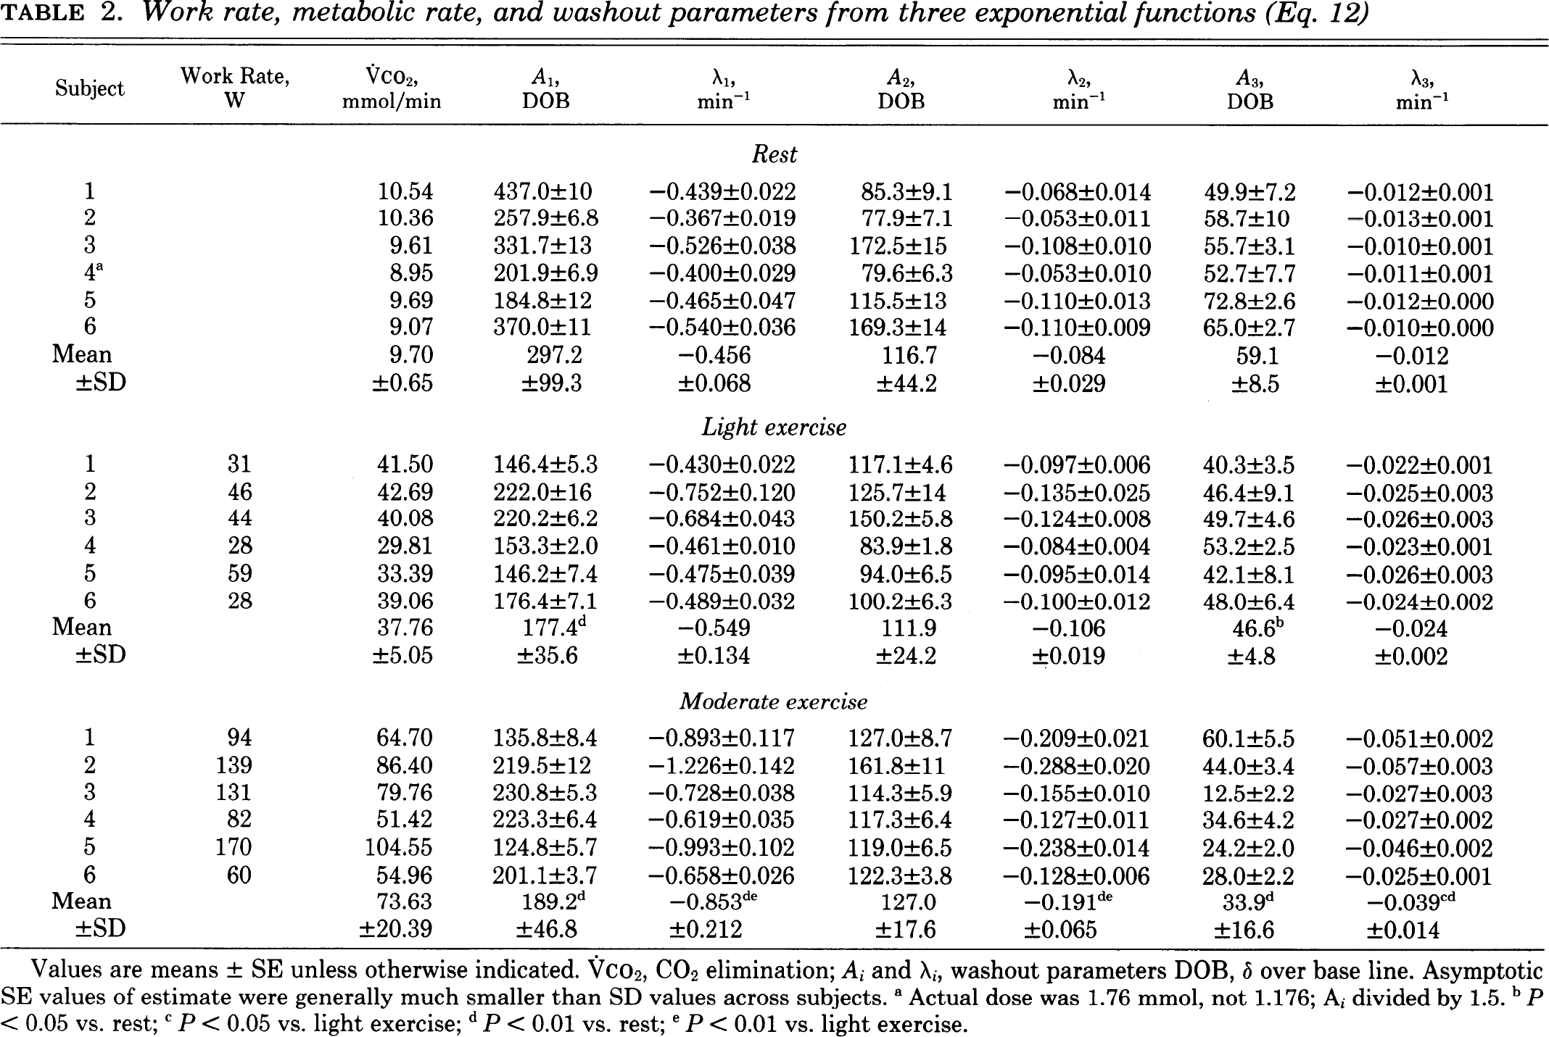

#### Roecker2001

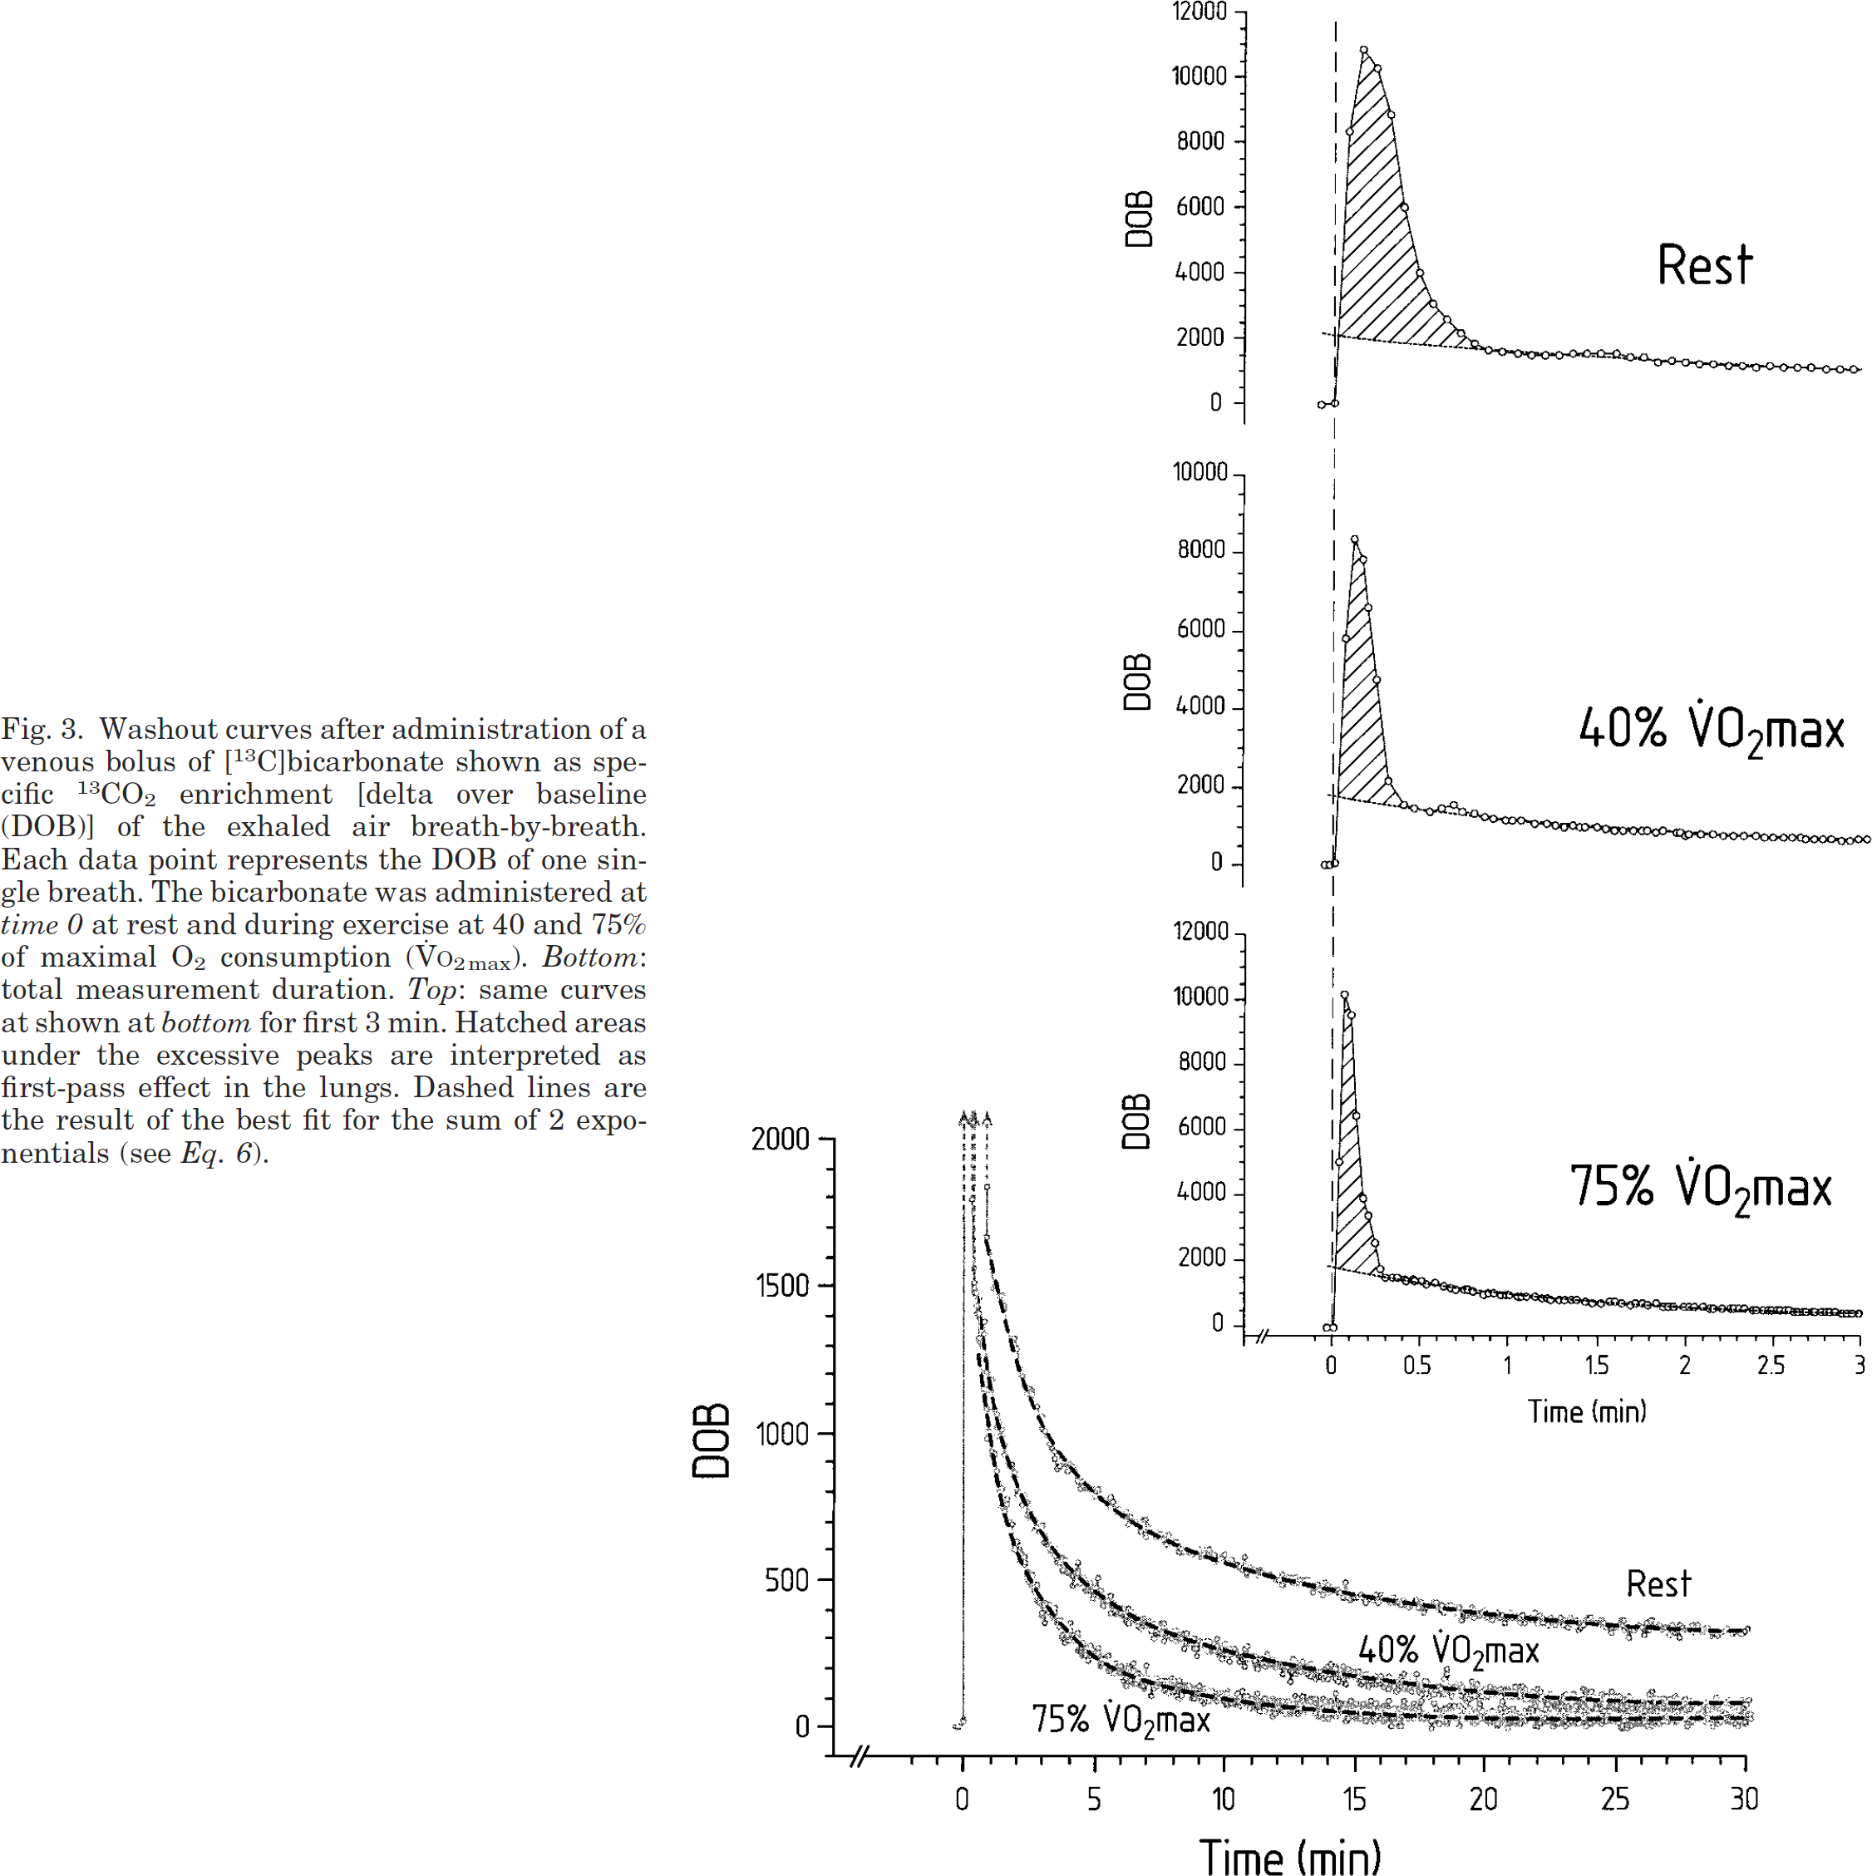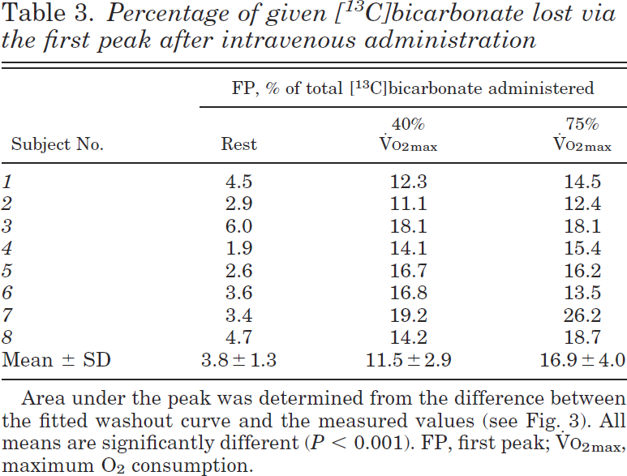

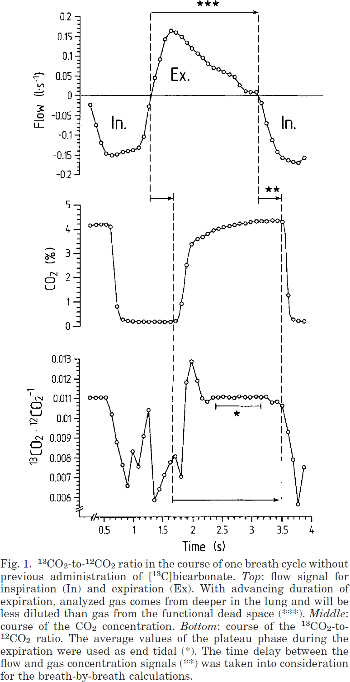

#### Slanger1970

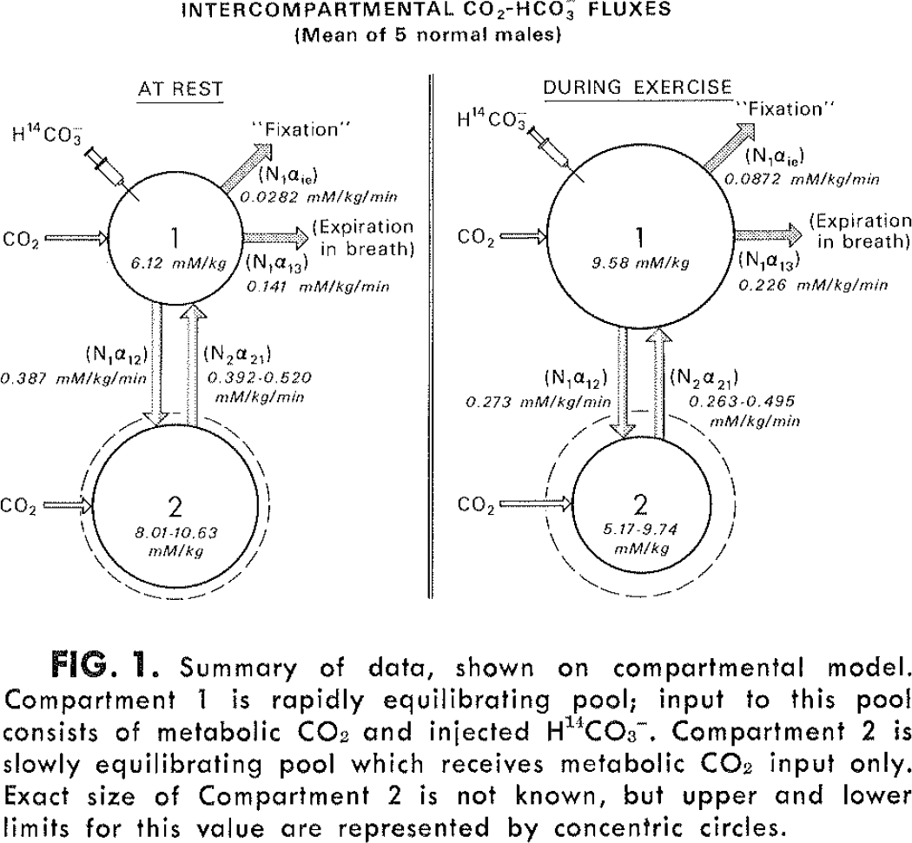

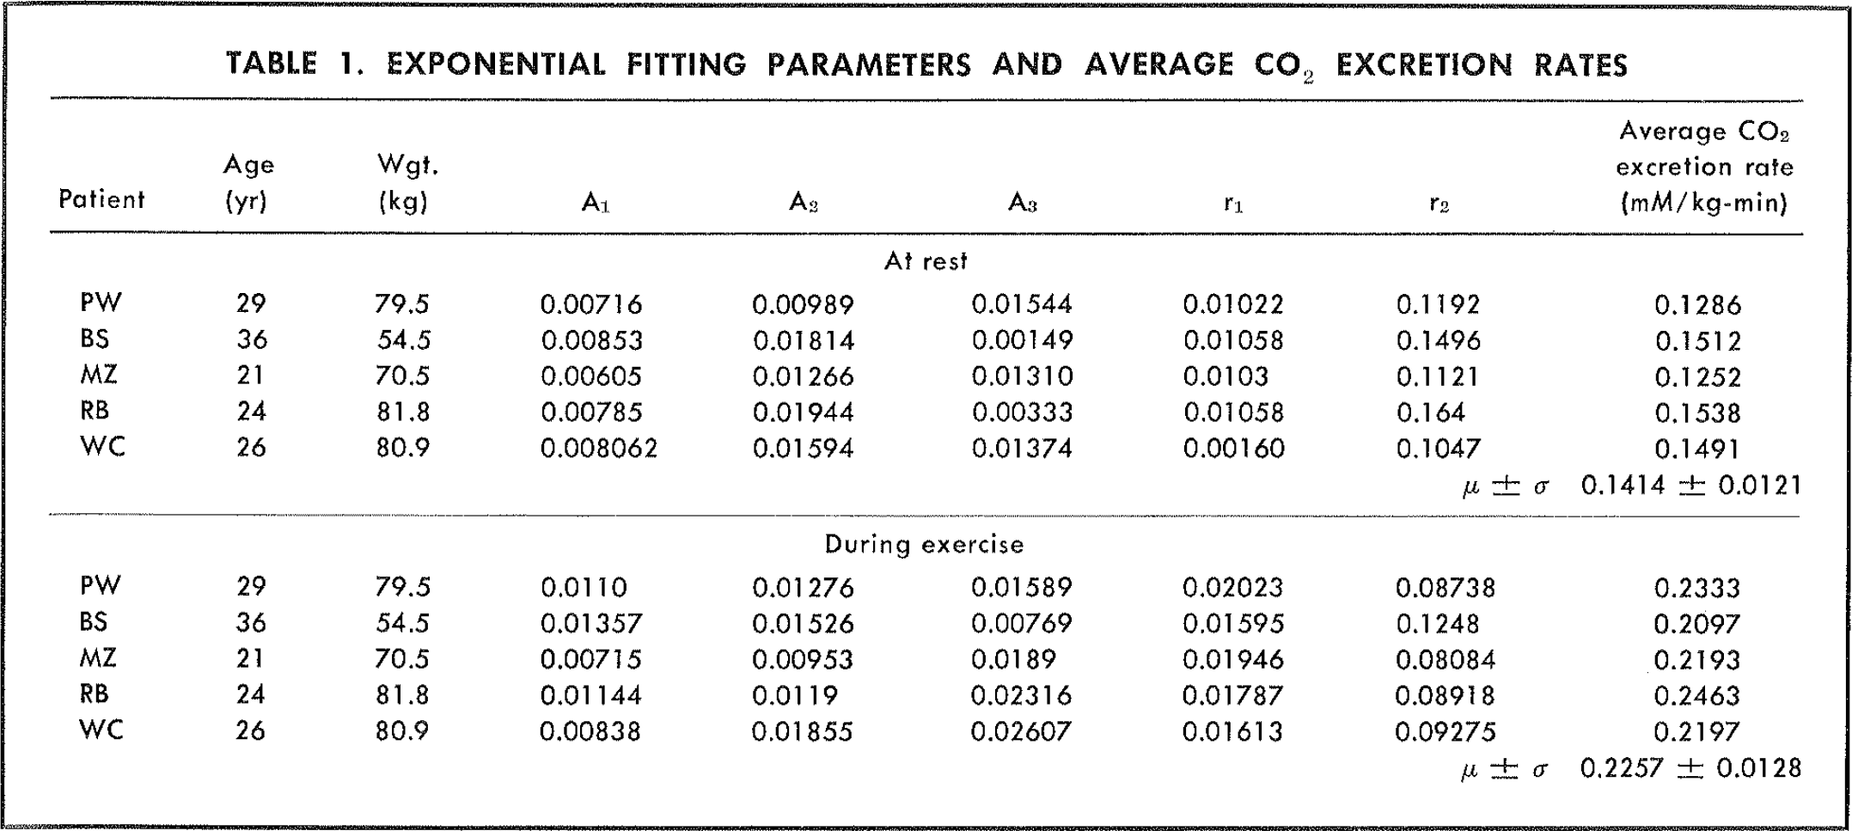

#### Zanconato1992

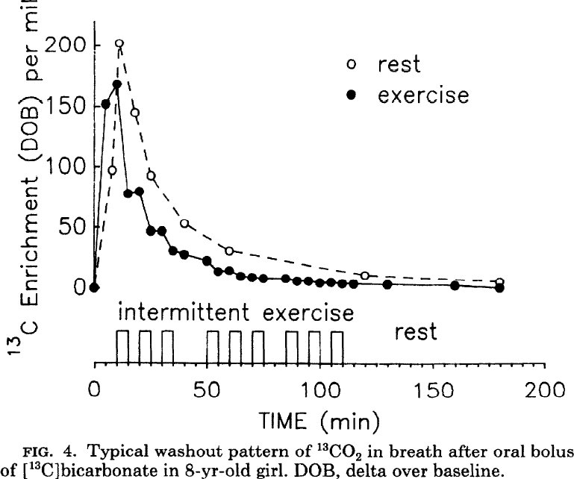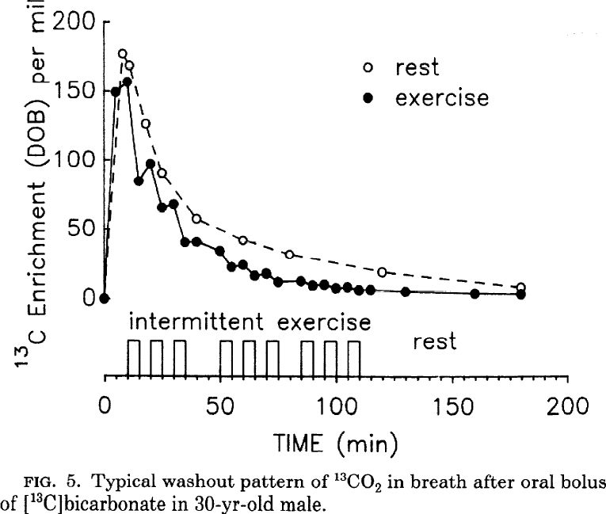

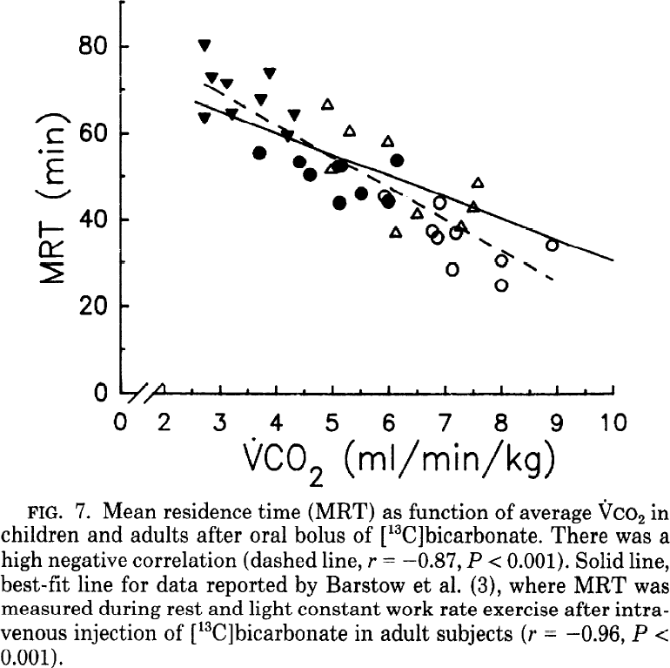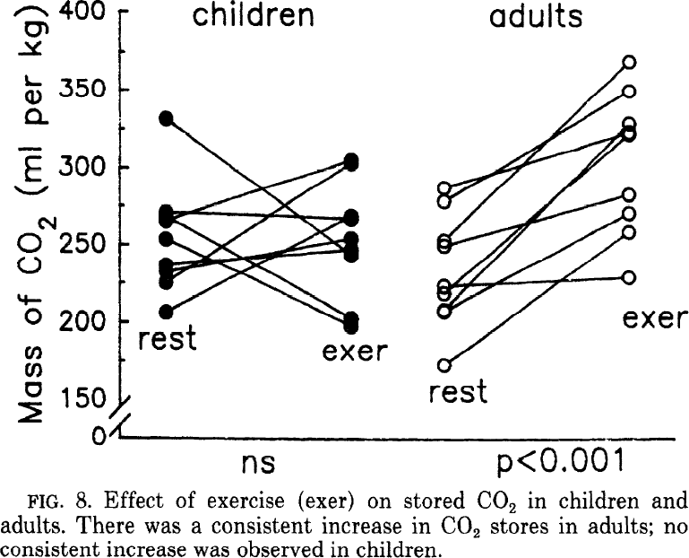

#### Barstow1992

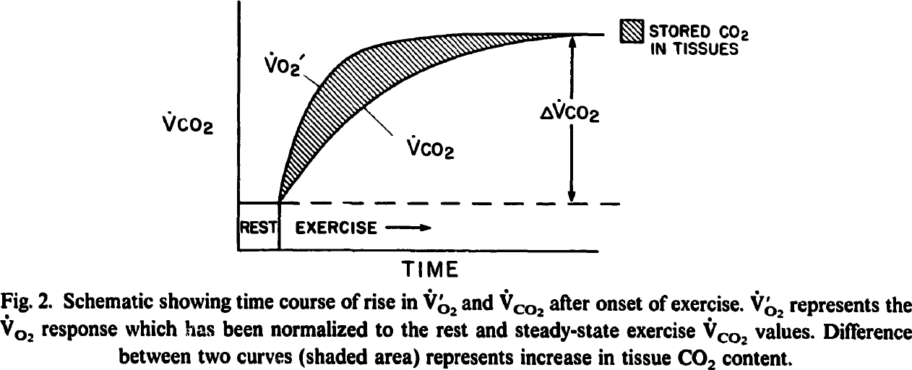

#### Hall1999

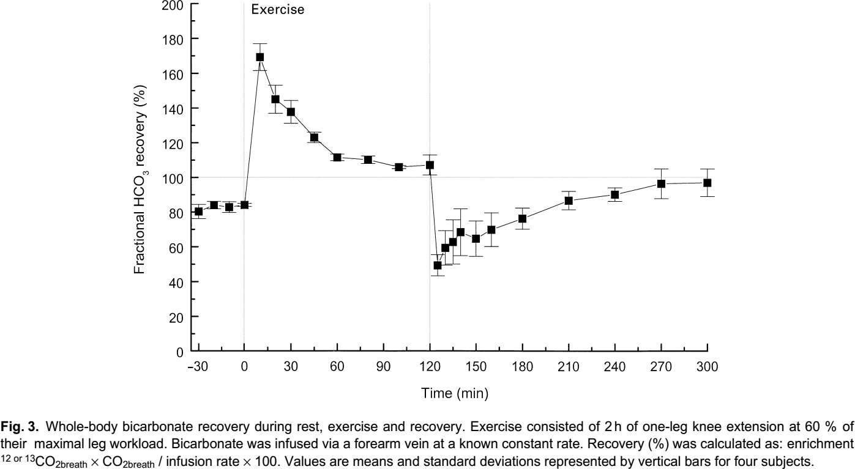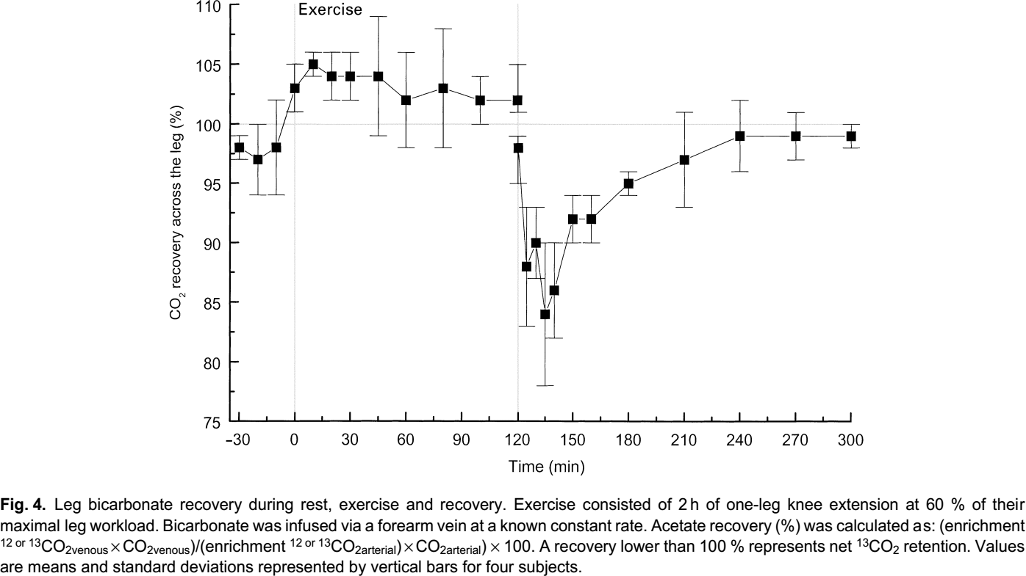

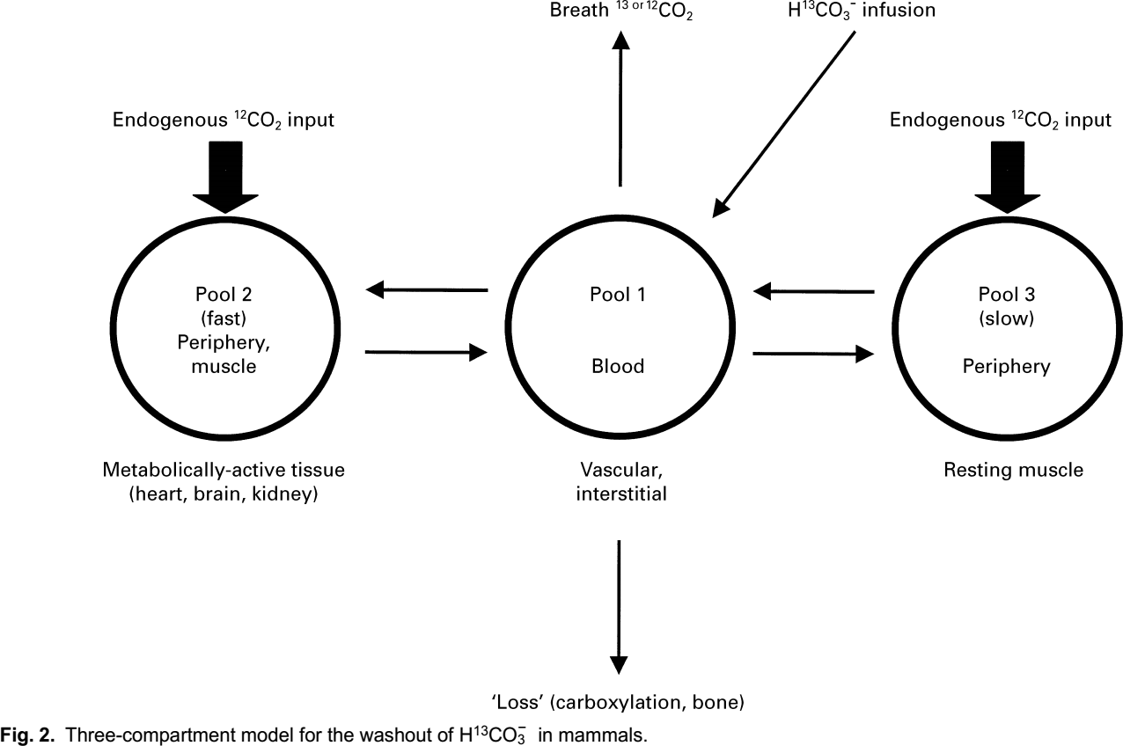

#### Leese1994

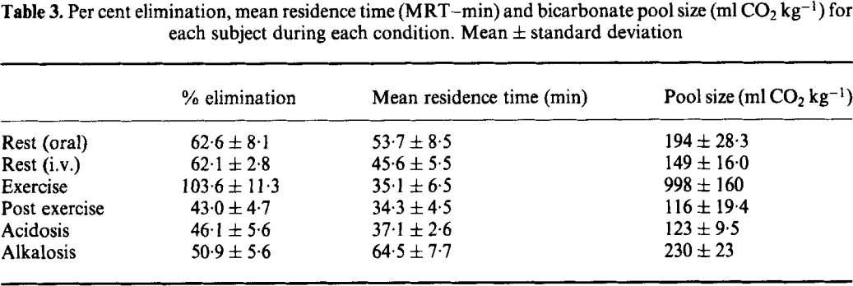

#### Wolfe1984

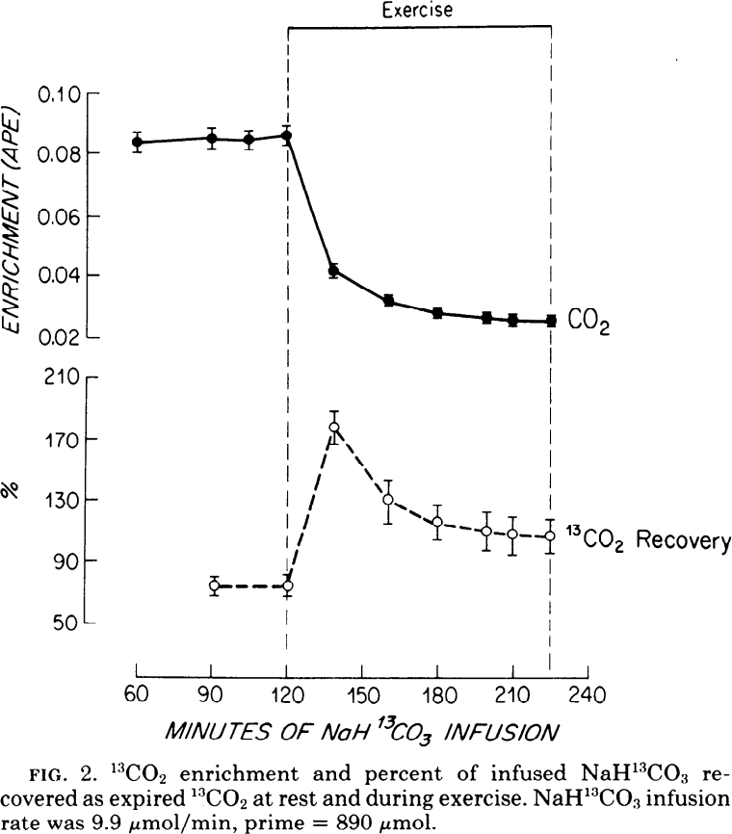

#### Tarnopolsky1991

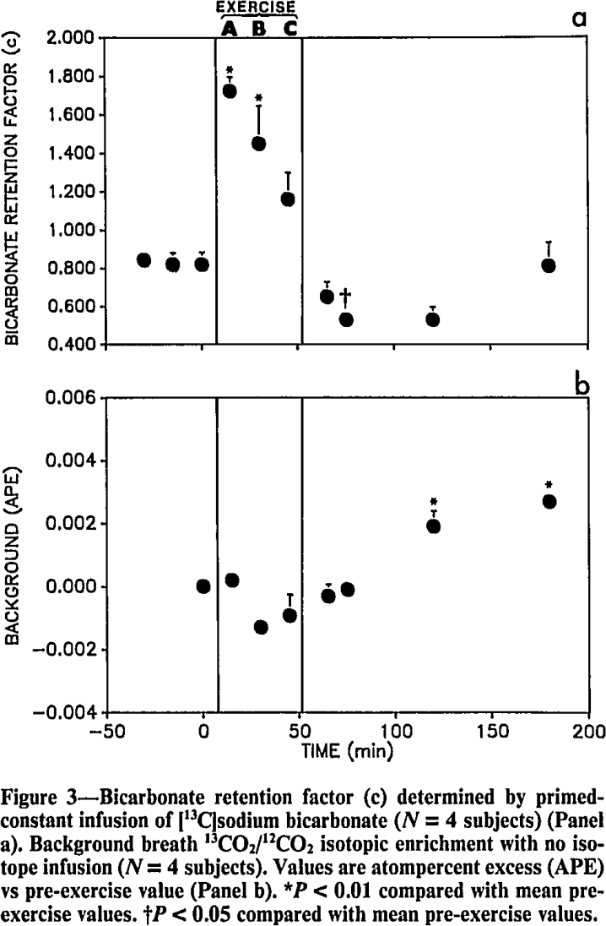

#### Henderson2007

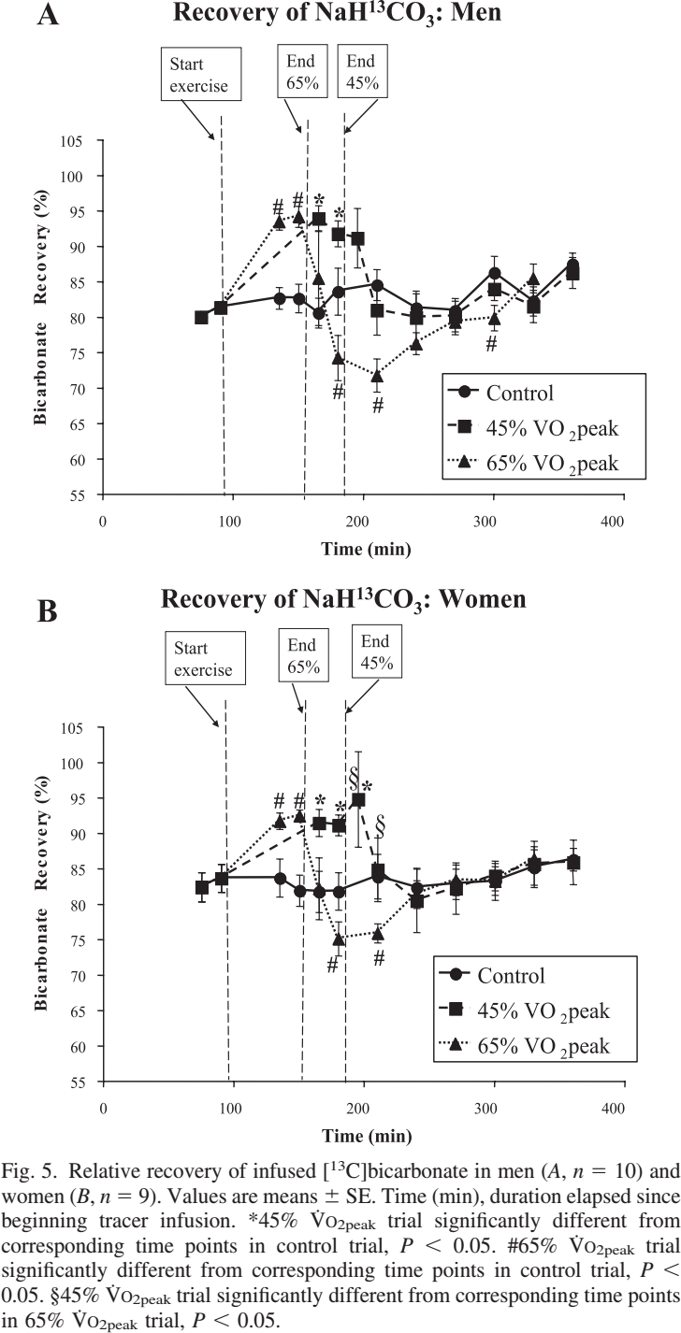

# Recovery & CO2 retention

* “**Recovery of injected bicarbonate** as labeled CO2 in the breath during resting conditions has been found to range between 50% and 90% [6, 11, 19-21, 34, 35] and is reported to decrease slightly with very mild exercise [31]”{Barstow1990}
* “CO2 retention has been suggested to occur mainly within the body store(s) of bicarbonate, although some labelled CO2 will be fixed in other metabolites via carboxylation reactions. The main bicarbonate body stores are thought to be within bone, intracellular reserves and metabolic intermediates. The extent of CO2 retention is usually assessed from the proportion of intravenously administered labelled bicarbonate (as a bolus or during constant infusion) that is recovered in breath. **In human subjects the recovery of labelled CO2 from administered bicarbonate varies from approximately 50 % to 100%. This large variation has been attributed to both methodological and biological variability** (for extensive review, see Leijssen & Elia, 1996).” {Hall1999}

#### Leijssen1996

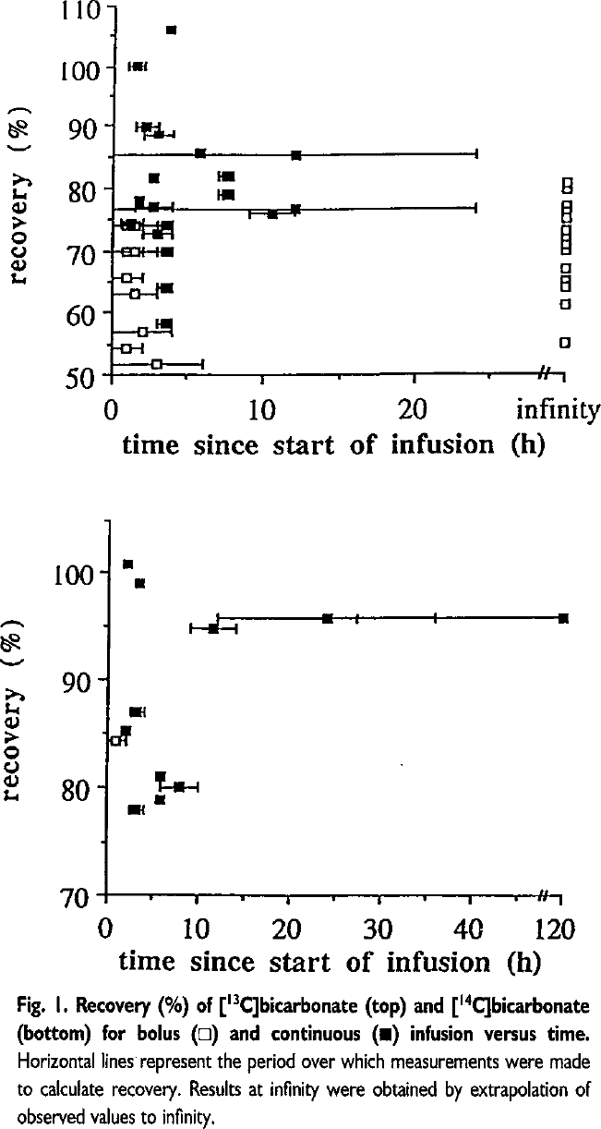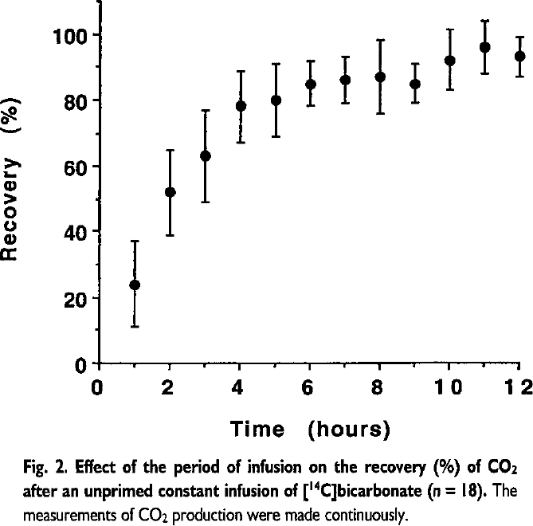

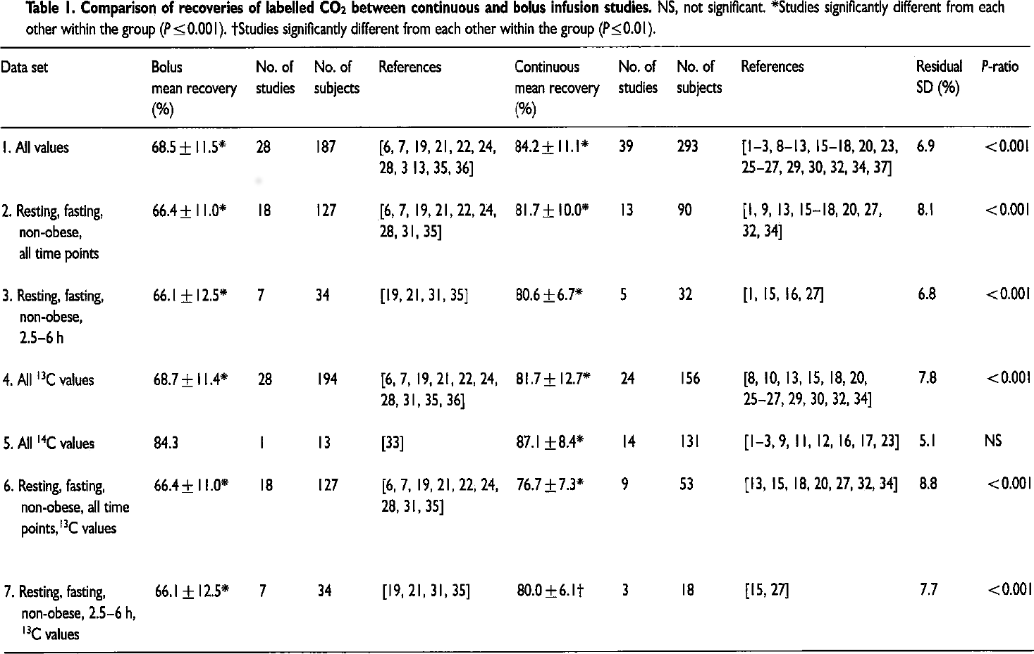

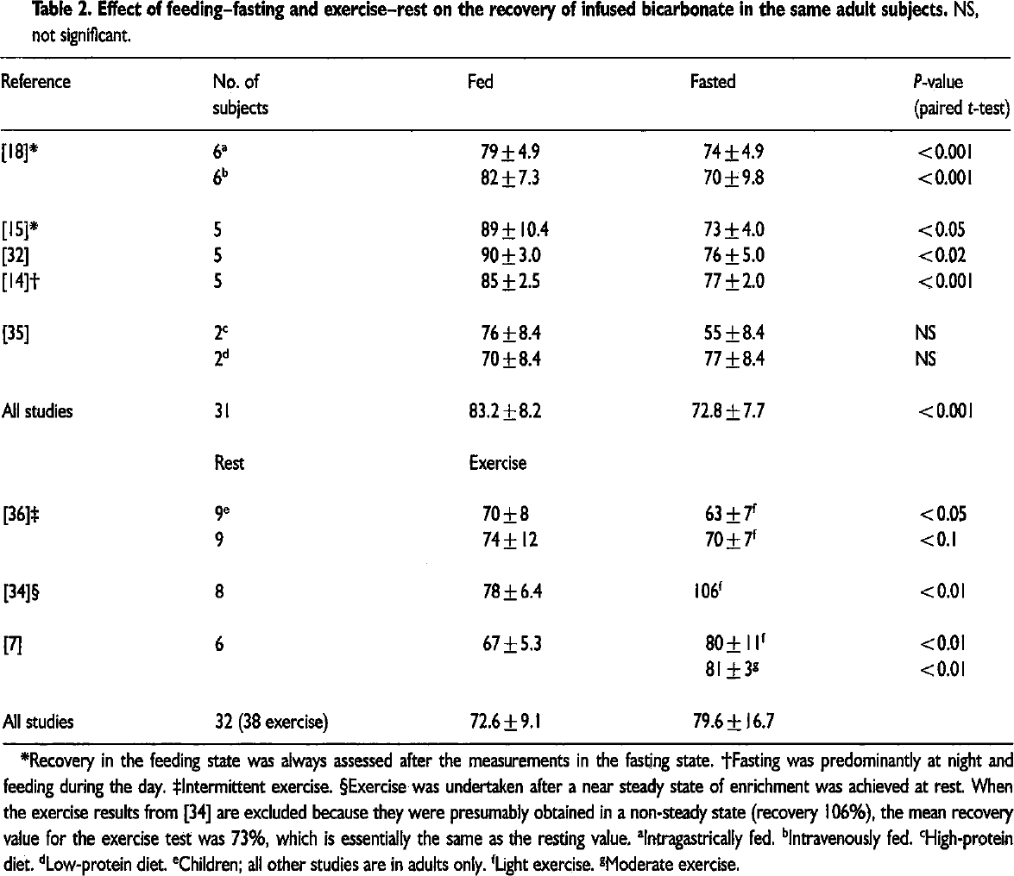

#### Leese1994

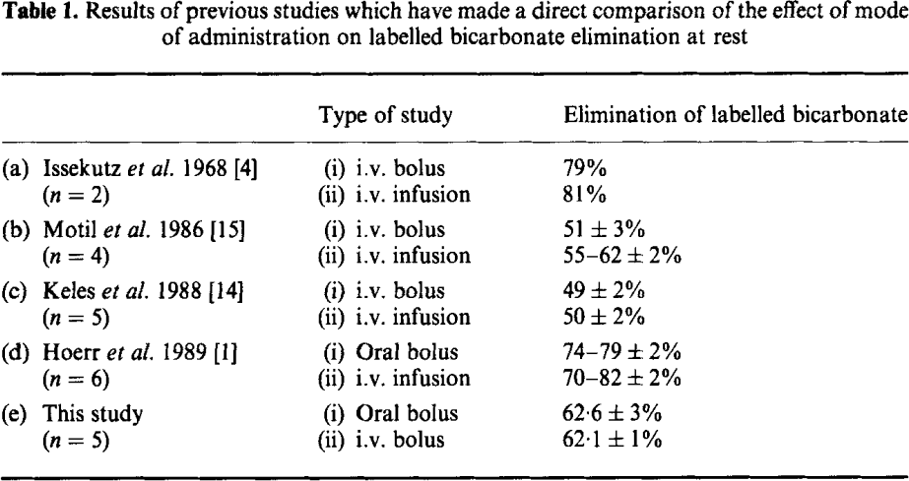

#### Barstow1990

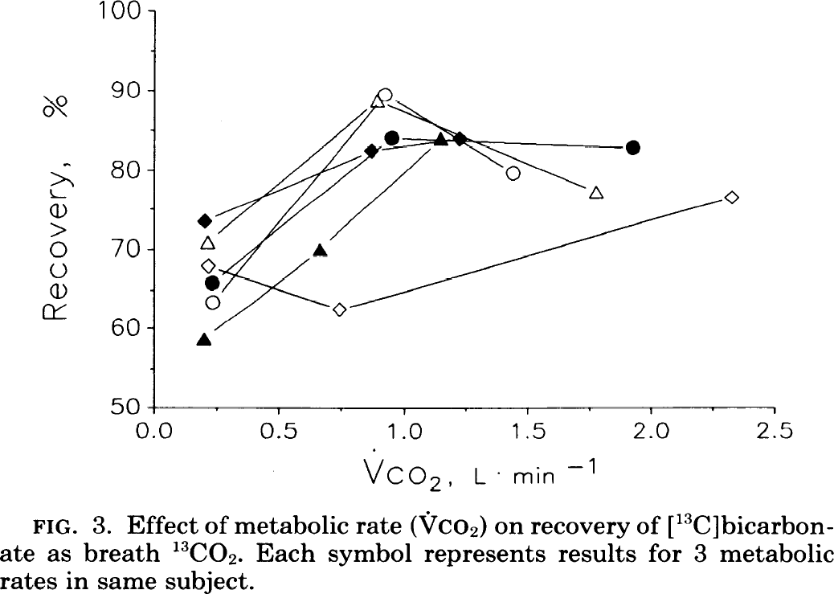

#### Elia1995

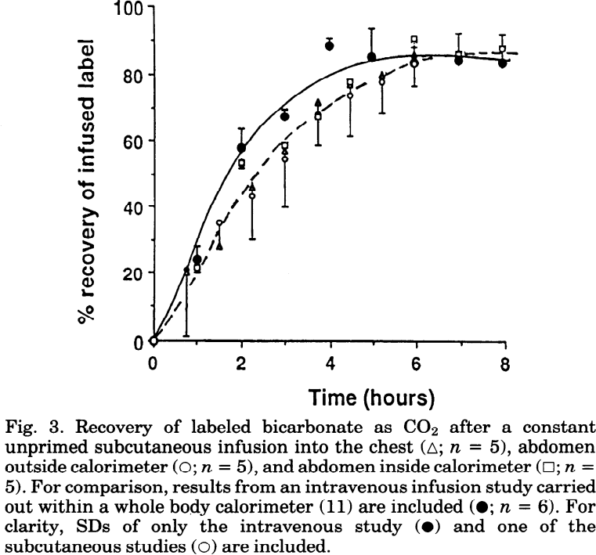

#### Hoerr1989

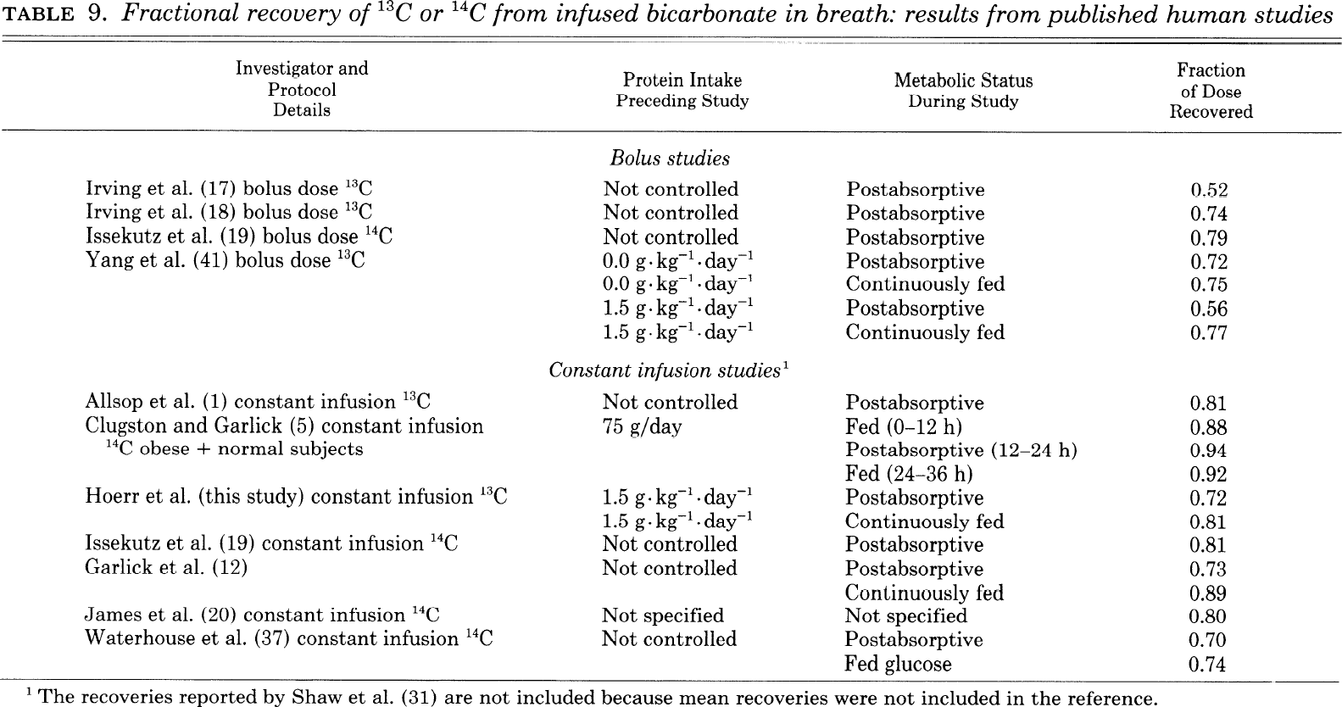

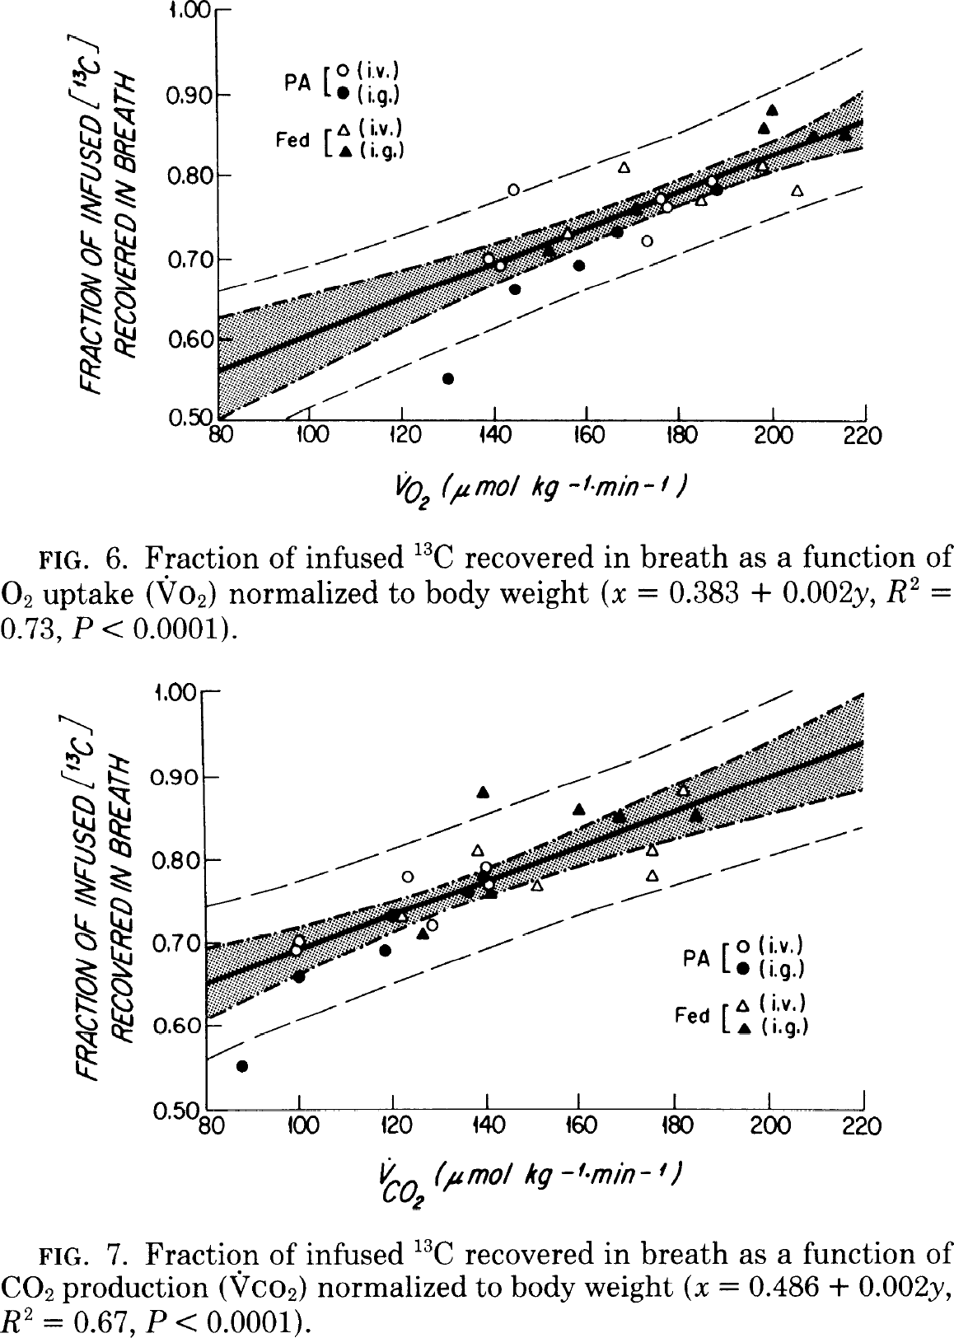

#### Irving1984

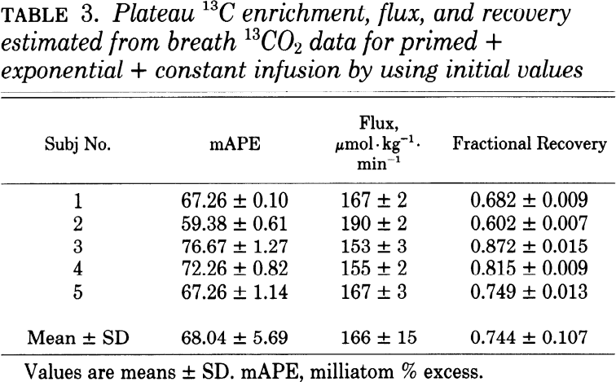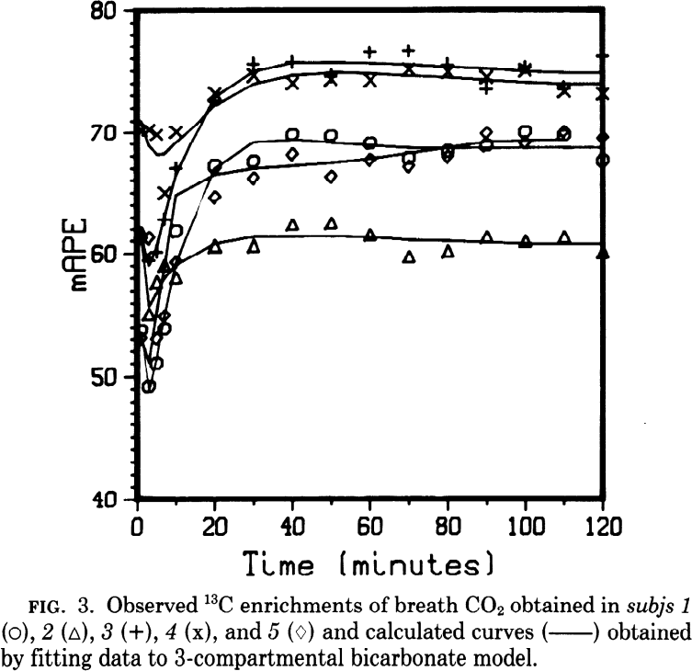

#### Spear1995

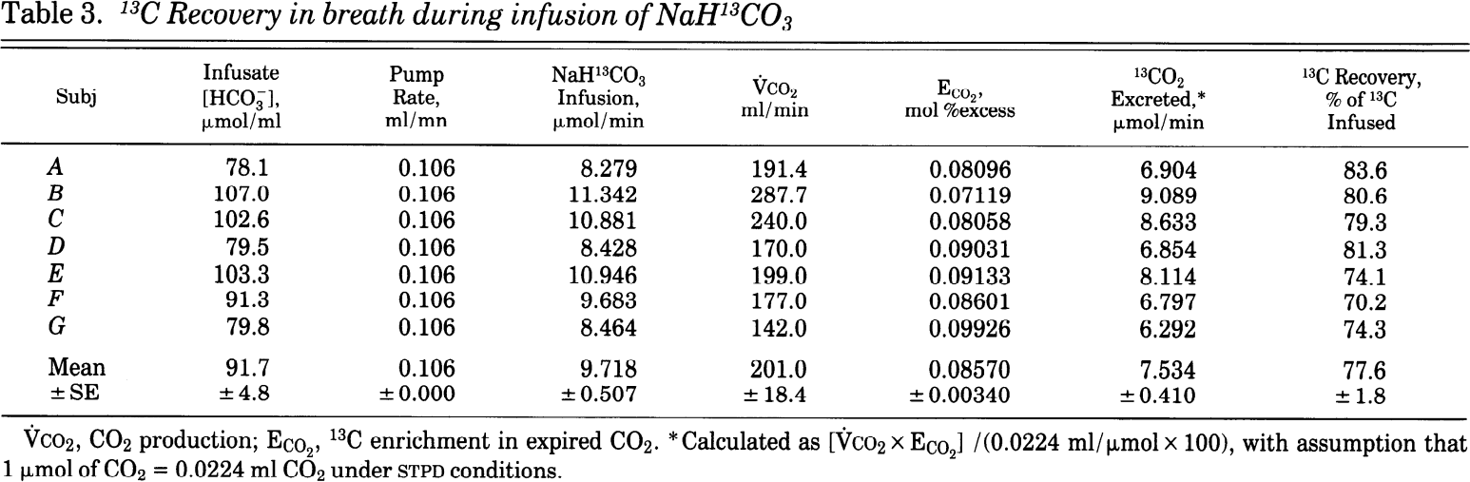

#### Clugston1983

* “By giving NaH14CO, and following the production of 14CO2, over periods between 2 h and 10 h, a number of groups have reported recoveries of 80-87% [1-3].” {Clugston1983}

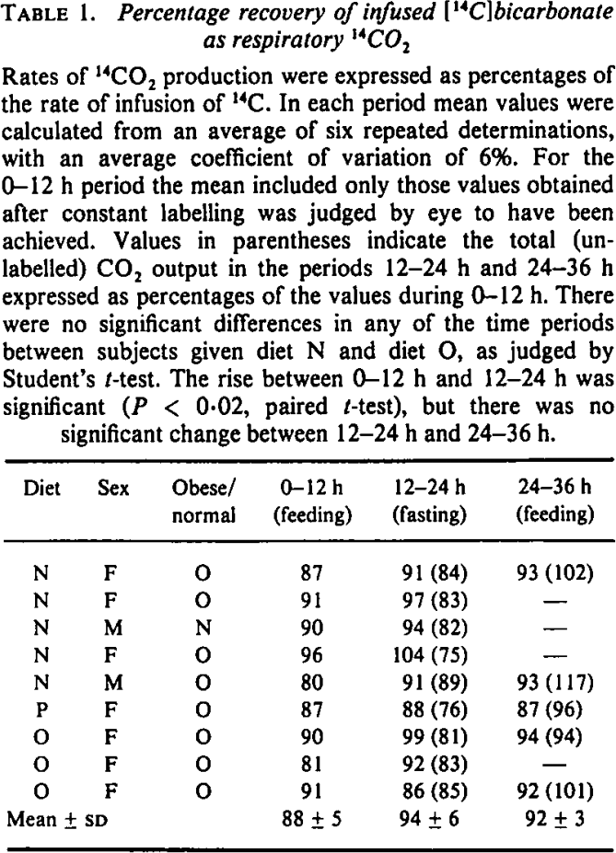

#### Issekutz1968

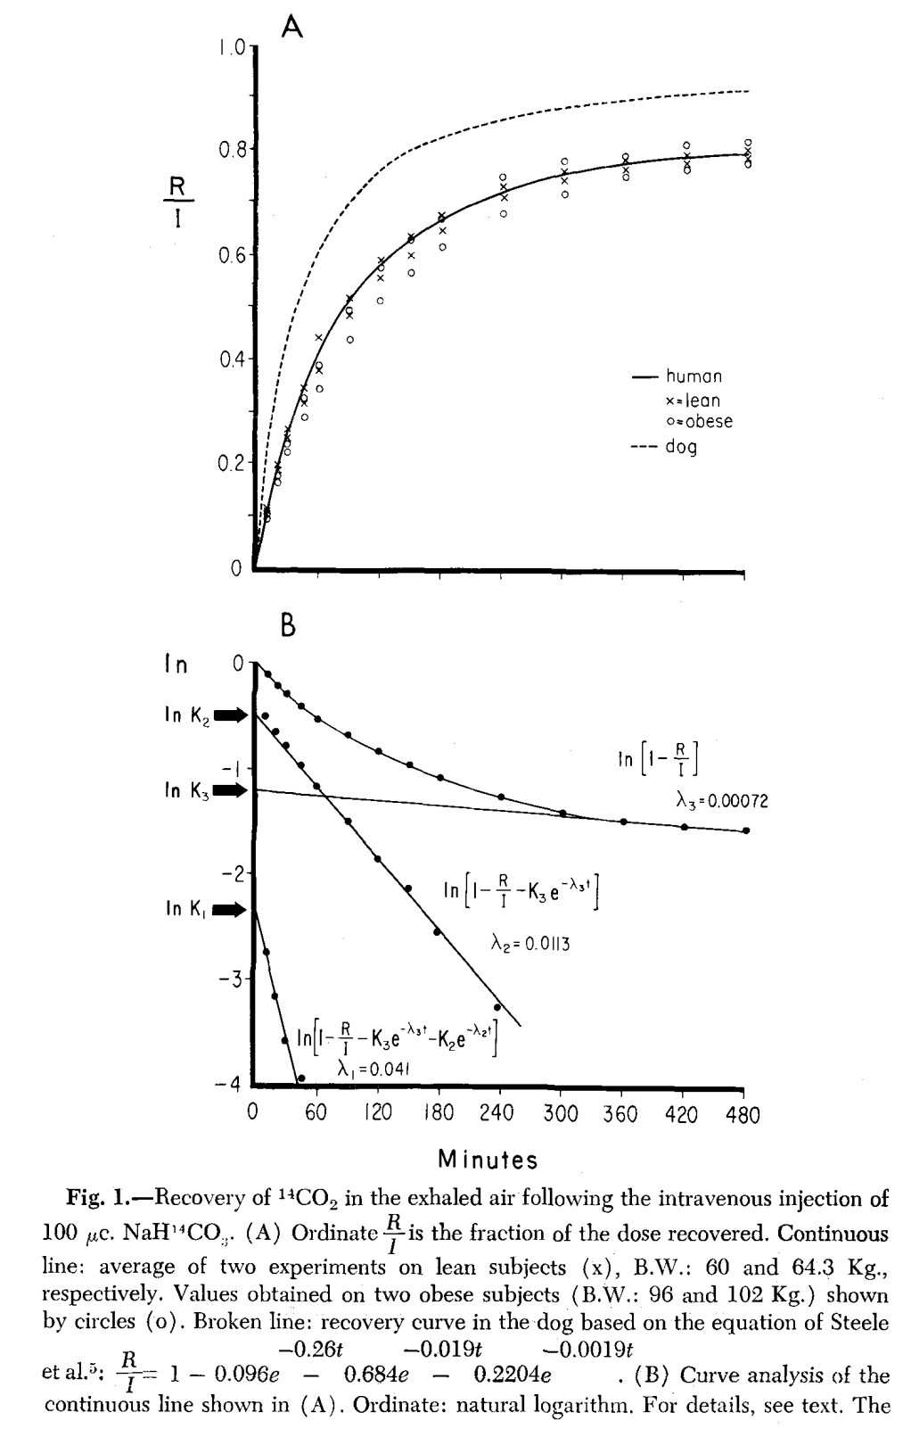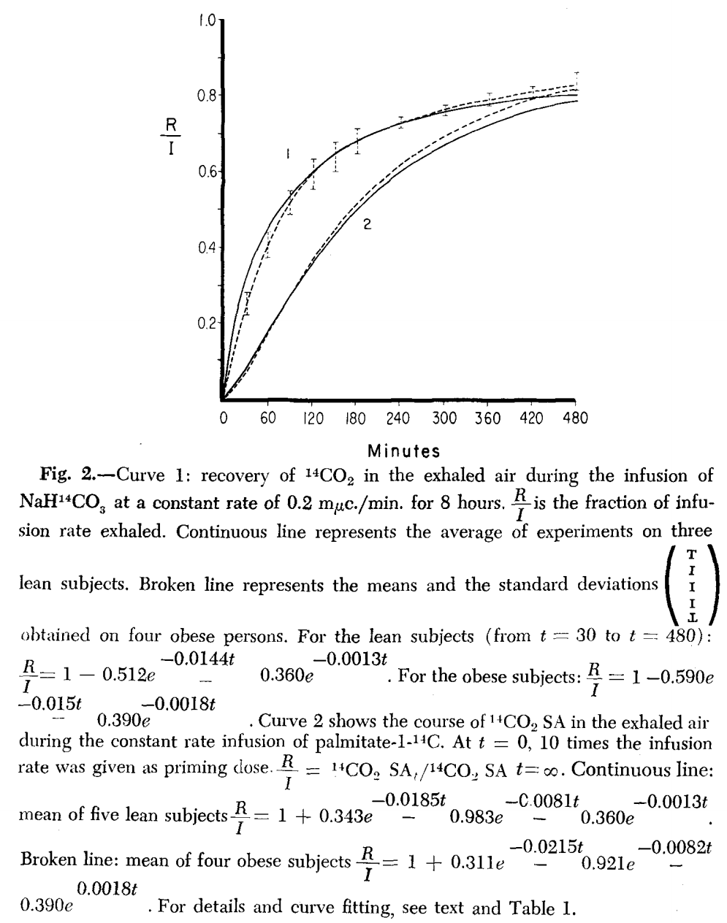

# Dose-dependency

#### Meineke1993

* “Oral administration at 5 doses between 12.5 and 100mg of 13C labelled sodium bicarbonate to 10 healthy subjects. The kinetics of 13CO2 (breath) were characterized by an apparent terminal elimination half-life of 1h and a mean recovery of 0.630 of the dose administered. **The kinetics were not dose-dependent**.“{Meineke1993}
* “The mean apparent terminal elimination rate constant of 0.63 [1/h] is also in excellent agreement with the value 0.60 [1/h] and 0.72 [1/h]”{Meineke1993}

“Day to day variation was less than 10%”{Meineke1993}

“**Average CO2-output of 96.9µmol/min/kg**, agrees well with the results after i.v. administration as reported by Irving (**101µmol/min/kg**), Winchell (**118-202µmol/min/kg**), Barstow (**139µmol/min/kg**) and Hoerr (**158µmol/min/kg iv, 157µmol/min/kg ig**), ”{Meineke1993}

“Generally absorption and distribution were completed within 50min”{Meineke1993}

“The molecular fractions then declined monoexponentially with time”{Meineke1993}

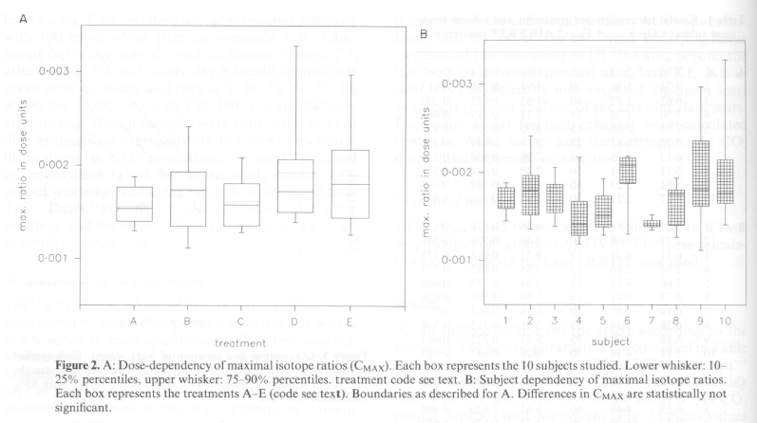{Meineke1993} Dose dependency.

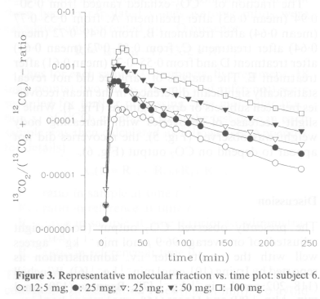{Meineke1993}

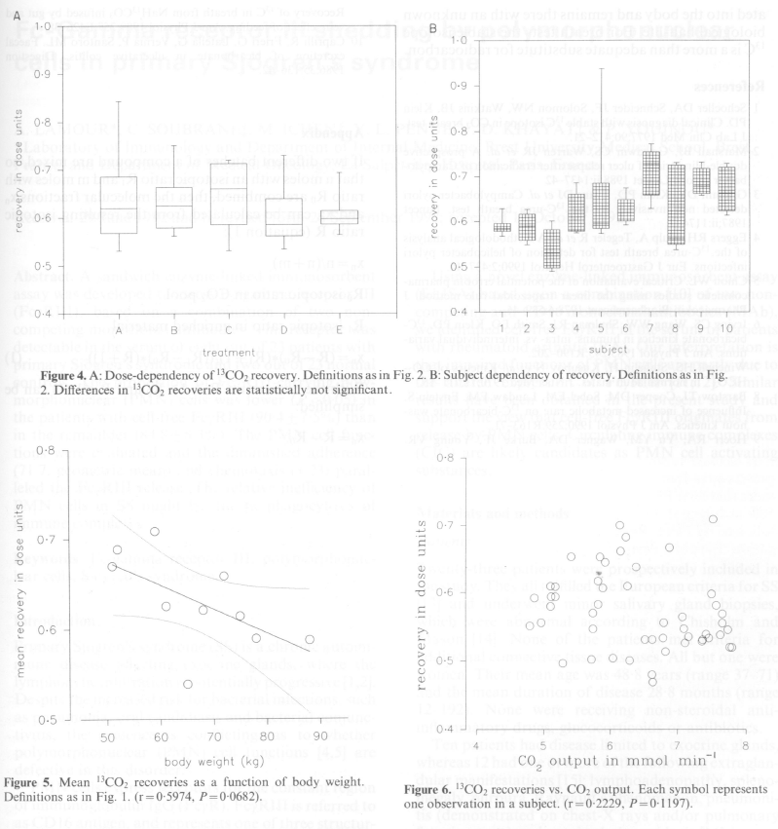{Meineke1993}

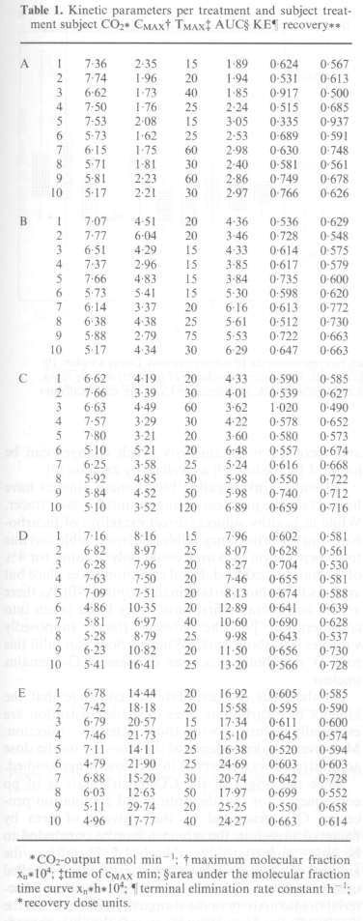{Meineke1993}

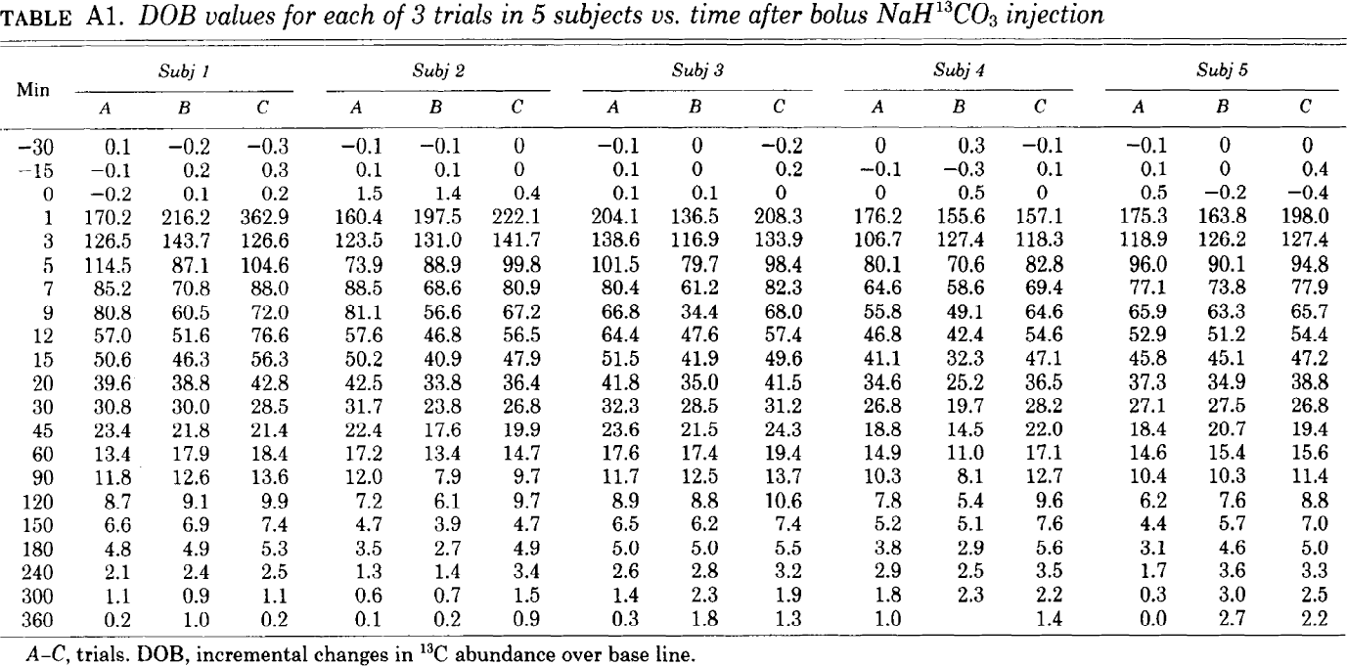

{Irving1983}

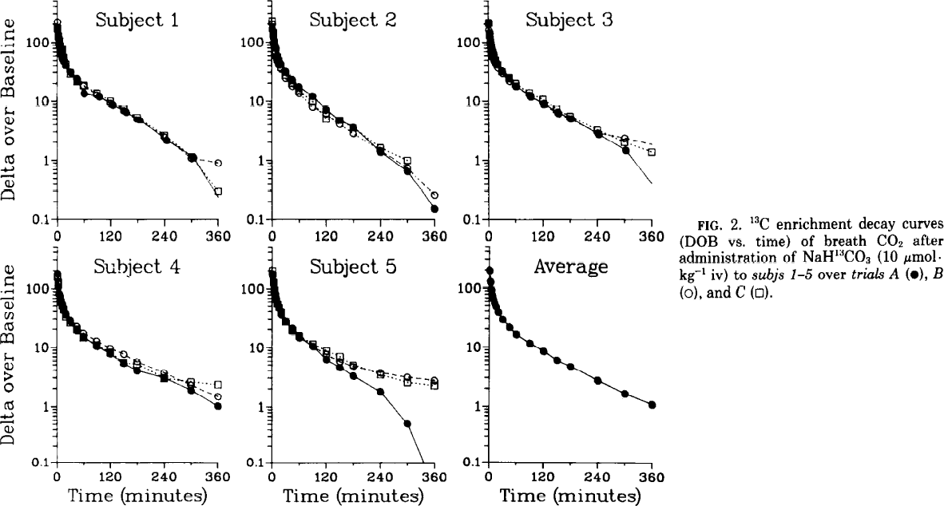{Irving1983}

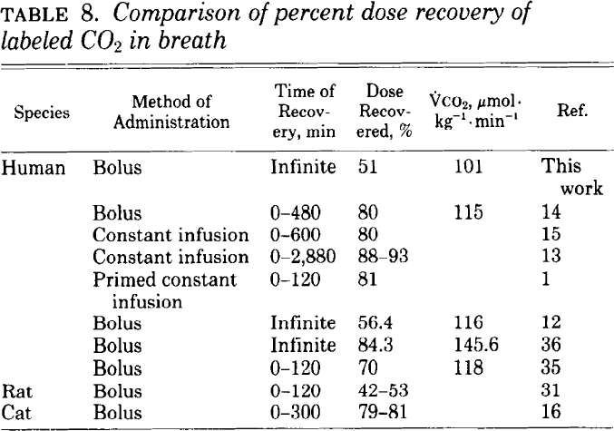{Irving1983}

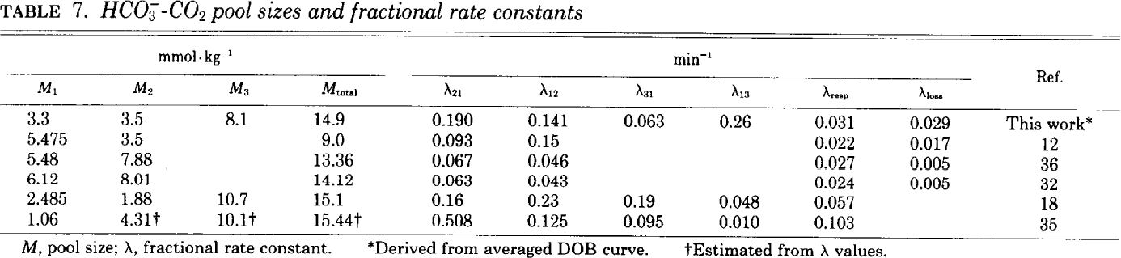{Irving1983}

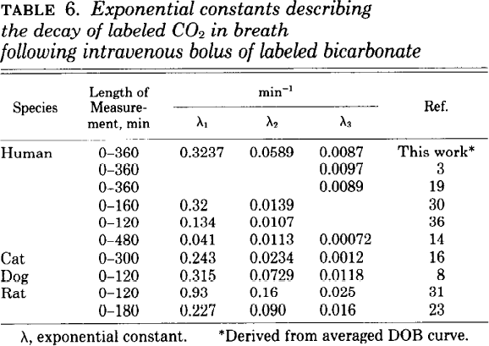{Irving1983}

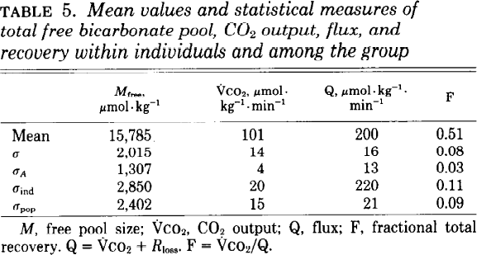{Irving1983}

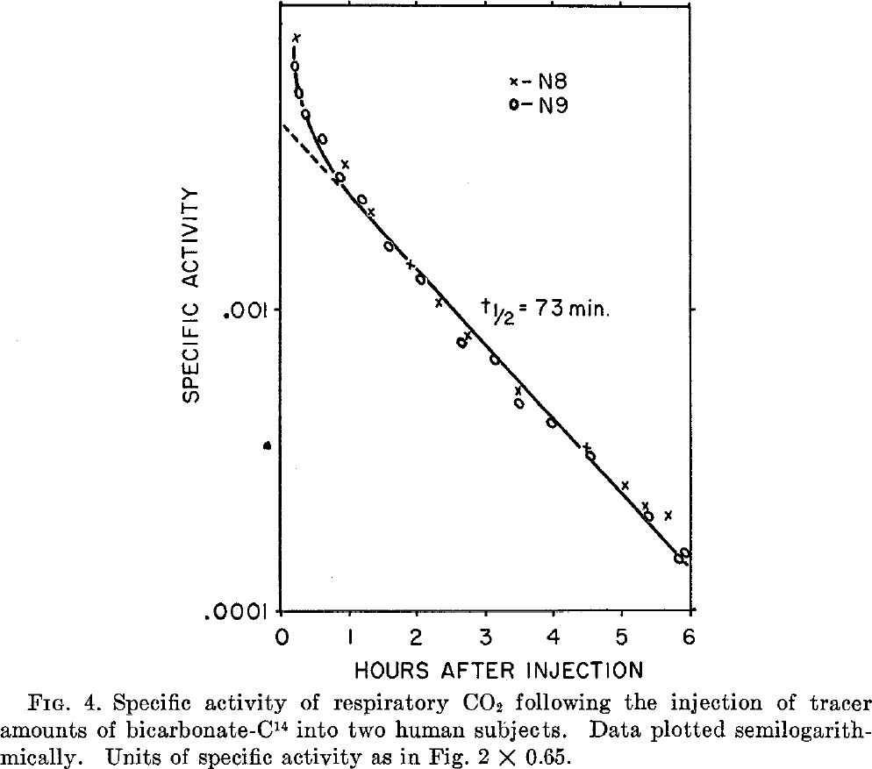{BAKER1954}

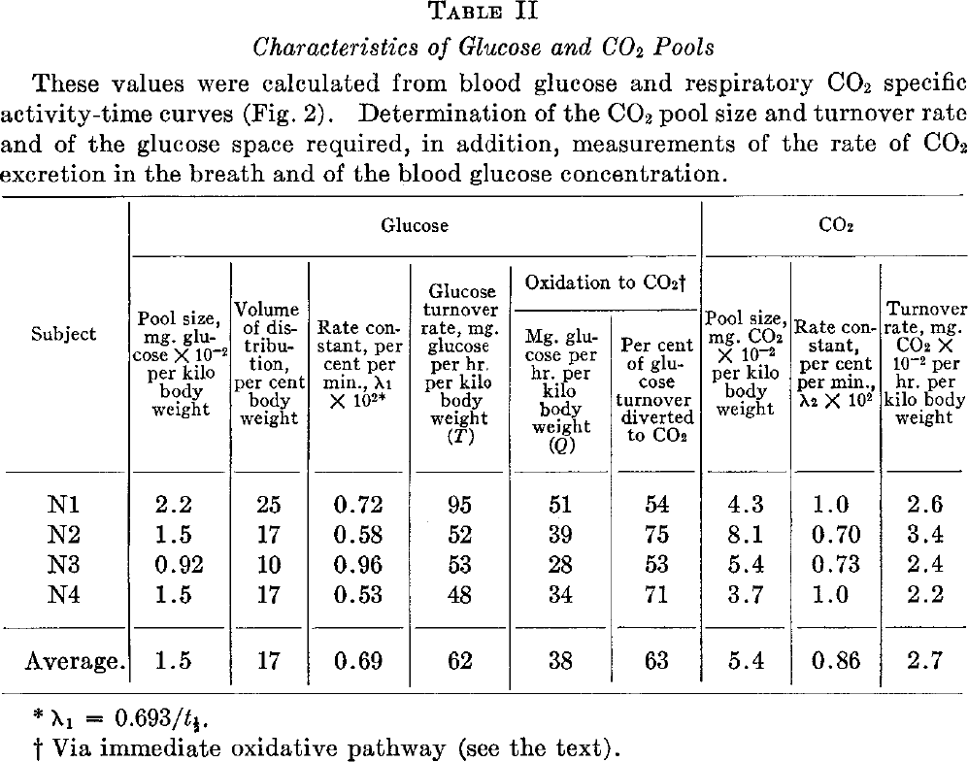{Baker1954}

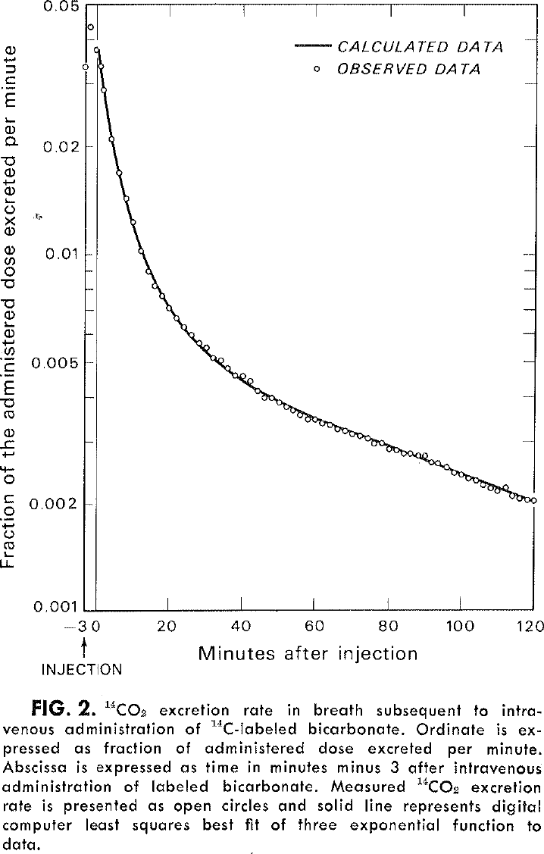{Winchell1977_Fig2}

#### Saccomani1995

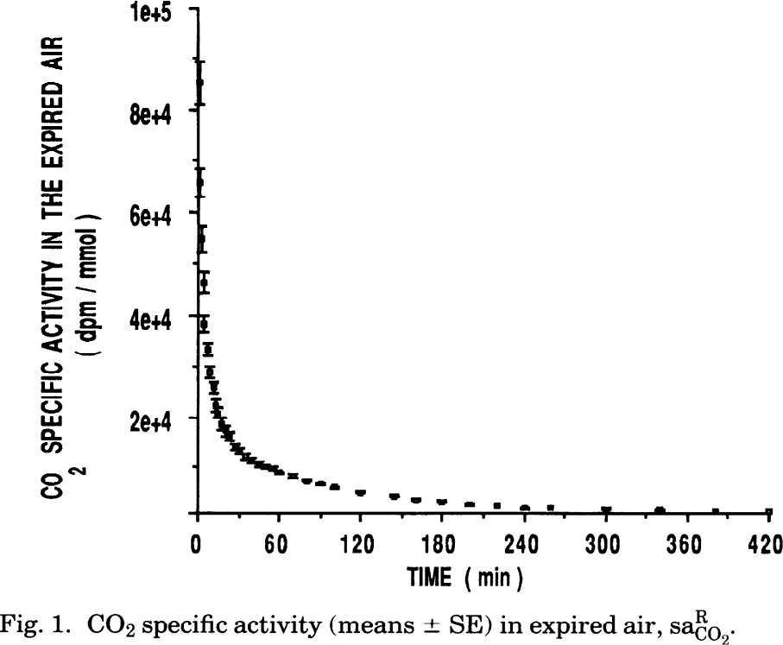

#### El-Khoury1994

#### 

#### Ray2006

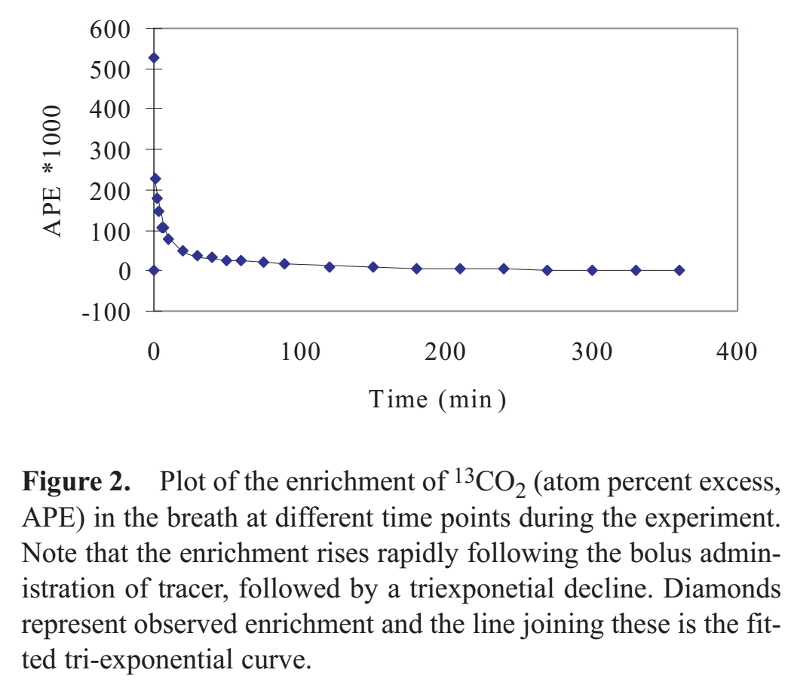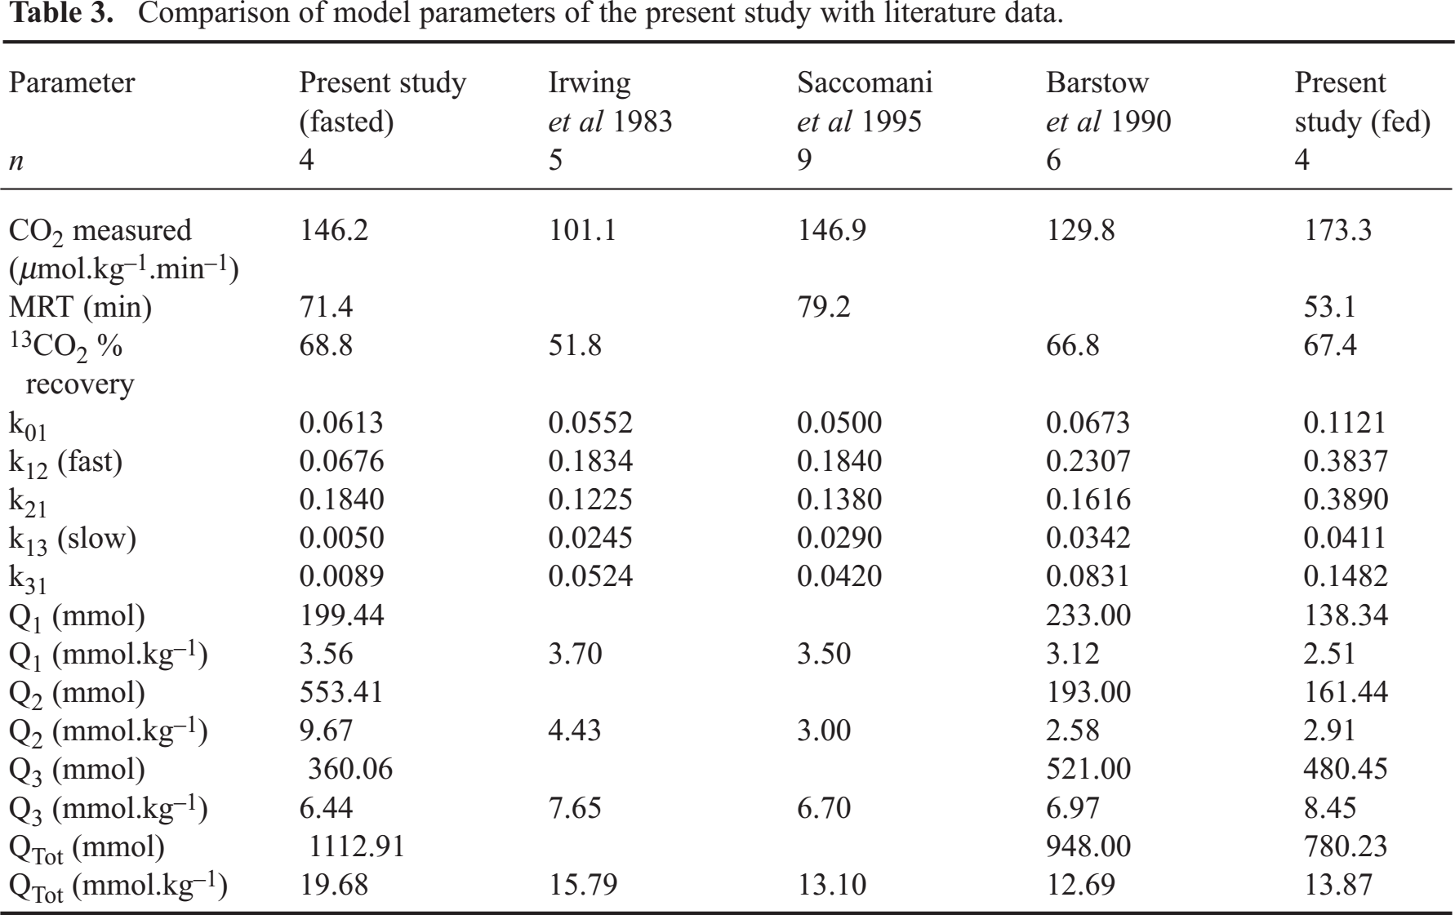

#### Hamel1993

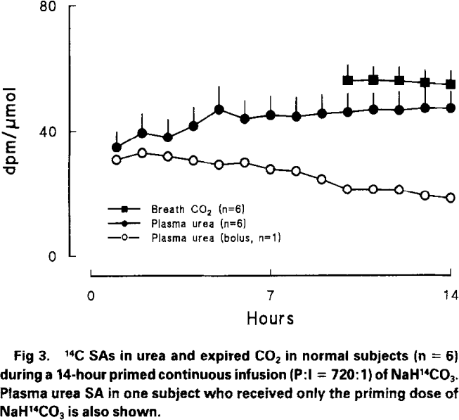

# Children

#### Armon1990

